



Keep the Knowledge
How do I do that?

A presenter’s guide for recordkeeping training in Australian Government agencies

Government Information Policy and Standards


© Commonwealth of Australia (National Archives of Australia) 2026
This product, excluding the National Archives of Australia logo, Commonwealth Coat of Arms and any material owned by a third party or protected by a trademark, has been released under a Creative Commons BY 4.0 (CC-BY 4.0) licence. Excluded material owned by third parties may include, for example, design and layout, images obtained under licence from third parties and signatures. The National Archives of Australia has made all reasonable efforts to identify and label material owned by third parties.
You may distribute, remix and build on this work. However, you must attribute the National Archives of Australia as the copyright holder of the work in compliance with its attribution policy available at naa.gov.au/copyright. The full terms and conditions of this licence are available at creativecommons.org/licenses/by/4.0/au.

Contents
Introduction 5
Application 5
Purpose 5
Acknowledging the National Archives 6
Presentation and facilitation tips 6
Key to symbols used in this document. 7
Supporting resources 7
Invitation to provide feedback 7
Slides and presenter’s notes 8
Slide 1 - Title slide 8
Slide 2 - Acknowledgement of Country 9
Slide 3 - Your records management responsibilities 10
Slide 4 - Topics covered in training session 12
Slide 5 - What is a record? 13
Slide 6 - Capturing records 15
Slide 7 - Email - Managing emails as business records 16
Slide 8 - Managing AI Generated Records: 18
Slide 9 - Where and how should records be stored? 19
Slide 10 - Describing records 21
Slide 11 - Systems and applications where I work 22
Slide 12 - Systems and applications where I work 24
Slide 13 - Network (shared) drives 26
Slide 14 - Sensitivity and access 27
Slide 15 - Digitisation 29
Slide 16 - Can I destroy or delete records? 31
Slide 17 - Records management advice and support 33
Slide 18 - Acknowledging National Archives of Australia 34
Slide 19 - National Archives of Australia 35

Introduction
Keep the knowledge - how do I do that? is a recordkeeping training package developed by National Archives of Australia (National Archives) for use by Australian Government agencies. We envisage that the information management trainer in an agency can use all or part of the package at their discretion to meet the business needs.
The package can be used to raise awareness of the responsibility all Australian Government employees, contractors, and consultants have, to make and keep records of their work.
The package covers:
- What is a record
- Recordkeeping responsibilities
- Recordkeeping processes
- Systems and applications that enable recordkeeping

Application
Keep the knowledge can be used by Australian Government agencies to provide in-house recordkeeping training to their staff, including:
- Staff inductions
- Refresher training for existing staff
- Records and information awareness raising campaigns
- As part of training and change management programs (for example when implementing new records management or business systems)
It provides a more tailored guide to recordkeeping in your agency. For the basics, staff should complete APS Foundations - Records Management
The following Keep the Knowledge material is available for use by Australian Government agencies:
- PowerPoint slideshow Keep the Knowledge presentation (for face-to-face training with groups)
- Keep the Knowledge presenter’s notes

Purpose
This guide has been developed specifically to assist agency information managers, trainers and other staff deliver the Keep the Knowledge - how do I do that? presentation in face-to-face training.
Presenter’s notes are suggested for each Keep the Knowledge presentation slide. These notes further explain the issues being addressed on the slide.
The guide also provides suggestions about:
- How the presentation slideshow can be tailored to include agency specific information.
- Optional discussion points where concepts can be explored, and information shared.
- Reference links to supporting resources available on the internet.

Acknowledging the National Archives
Full acknowledgement must be given to the National Archives for content used or adapted from the Keep the Knowledge package.
This must be done by using the last slide, or the content of the last slide, and presenting or publishing the acknowledgement text found in the presenter’s notes on slide 17 of this guide.
Copyright of the Keep the Knowledge training package, including the presentation slideshow and presenter’s notes, rests with the Commonwealth of Australia. National Archives administers that property.
National Archives strongly encourages Australian Government agencies to adapt and modify the presentation slideshow and presenter’s notes to suit their specific needs. However, for copyright reasons agencies must ensure:
- The adapted or modified content is not used for commercial purposes or sale, such as training for a fee; and
- Use or modification of Archives’ material is fully acknowledged.

Presentation and facilitation tips
- Using the presentation slideshow off-the-shelf will take approximately 1 hour to present. This includes time for discussion and questions. Modifications made to the presentation may change this timing.
- Practise your presentation aloud and use your own words, remember you can modify the presentation in a way that meets your needs.
- Provide opportunities for your audience to contribute and be involved in the learning. There are instructions in some sections of the presentation which have the option to discuss the course content with participants.
- Allow sufficient time to share and discuss information and concepts in the presentation.
- After the presentation make notes about what went well and what could be improved. Review and consider modifications for any future sessions.

Key to symbols used in this document.
 | Suggestion for customising the presentation to suit your needs
 | Optional interactive discussion
For more information | Resources that can be shared with staff or used exclusively by the trainer to provide more information about topics are included in the training package

Supporting resources
The following resources are suggested to help you prepare to deliver this training:
- Information management | naa.gov.au
- Getting started with information management | naa.gov.au
- Information Management Standard for Australian Government | naa.gov.au
- Building trust in the public record | naa.gov.au
- Professional development and support | naa.gov.au
- Training resources | naa.gov.au

Invitation to provide feedback
Your feedback to National Archives on the effectiveness of using the Keep the Knowledge products is greatly appreciated. Your comments will help us further develop products that are useful resources for agencies to promote better records management practices.
How to provide feedback to the National Archives:
Email your feedback to information.management@naa.gov.au . We are interested in any comments you might have and have listed some questions below to help prompt your response:
- How useful was the content? What was useful, and what was not useful?
- How did you modify the materials (PowerPoint slides and presenter’s notes)?
- How useful were the links to resources in the guide? What other references would be useful?
- Were the Keep the Knowledge resources (PowerPoint slides and presenter’s notes) easy to access?
- Whatfeedback have you received from staff attending the training?

Any other suggestions, or comments with your experience using the Keep the Knowledge resources, are welcomed.

Slides and presenter’s notes

Slide 1 - Title slide


Presenter’s notes
This presentation outlines the basic principles of what everyone working for or with the [insert your agency] needs to do to create, keep and manage records.

This slide can be used for welcoming participants to the session and going through housekeeping information.

Slide 2 - Acknowledgement of Country
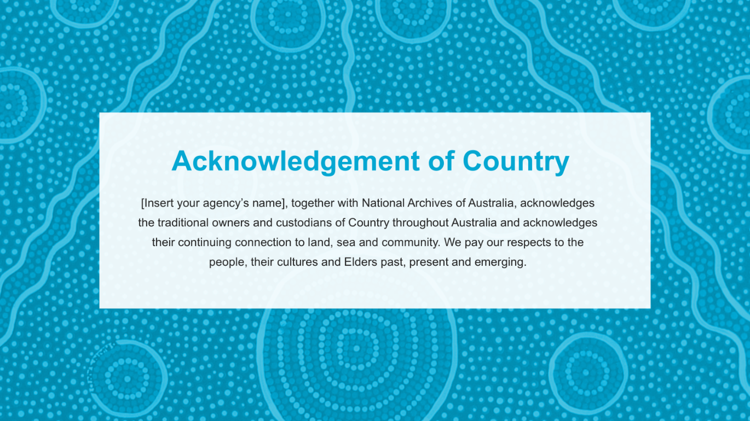
Update with your local traditional owners and custodians for the land where you are training.

Slide 3 - Your records management responsibilities
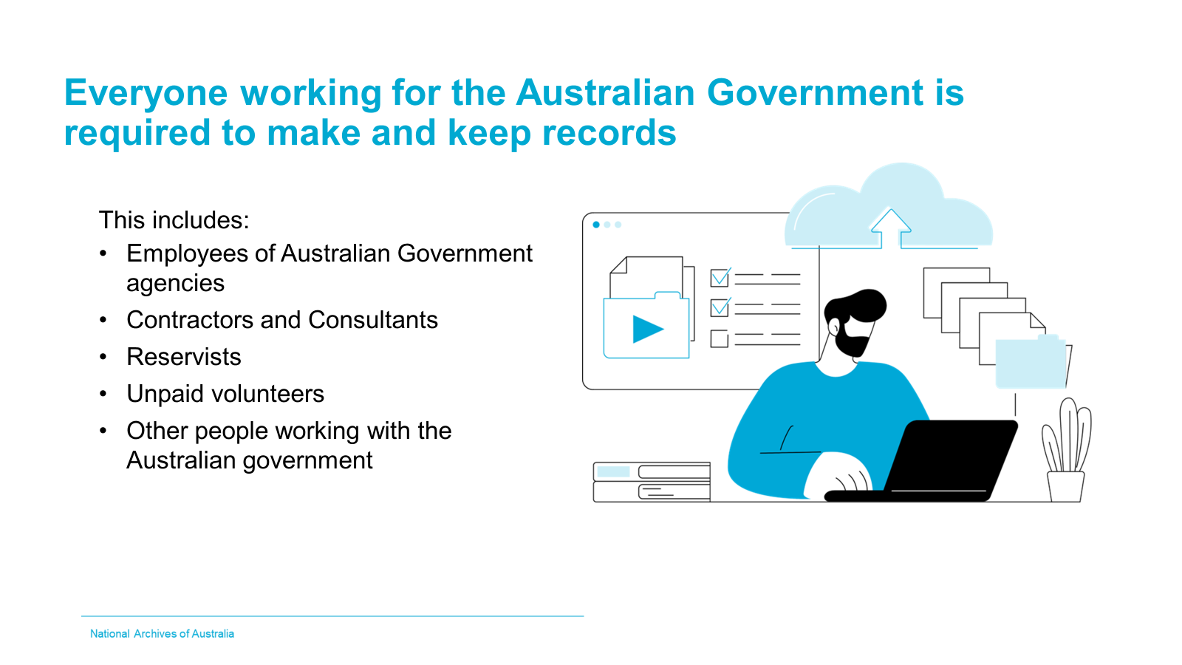
Presenter’s notes
As an Australian Government employee or someone working with the Australian Government, we all have records management responsibilities. These responsibilities extend to all consultants or volunteers.
Creating and keeping records helps you:
- Find and use the information you and your colleagues need to do your job.
- Produce evidence when required to explain or justify a decision or action.
- Re-use good work done in the past
- Ensure future generations understand Australia’s history, society, culture and people
Importantly, they provide evidence of what your agency has done and why. Therefore, records are an essential part of an accountable and transparent government.
This is why responsibilities towards records are embedded in the authorities which govern our work as APS employees, including:
- APS Values, APS Code of Conduct, which sets expectations for records in support of integrity, stewardship, accountability and commitment to service.
- The Public Governance, Performance and Accountability Act 2013, which specifies agencies create and keep records to document their performance.
We understand that meeting this responsibility can at times be challenging, so today’s course is here to help you understand these responsibilities and how we can work together to meet them. Essentially: ‘how do I do that?’. (with reference to the presentation title)

For more information
- APS Foundations – Records Management
- Information Matters (youtube.com)

Slide 4 - Topics covered in training session
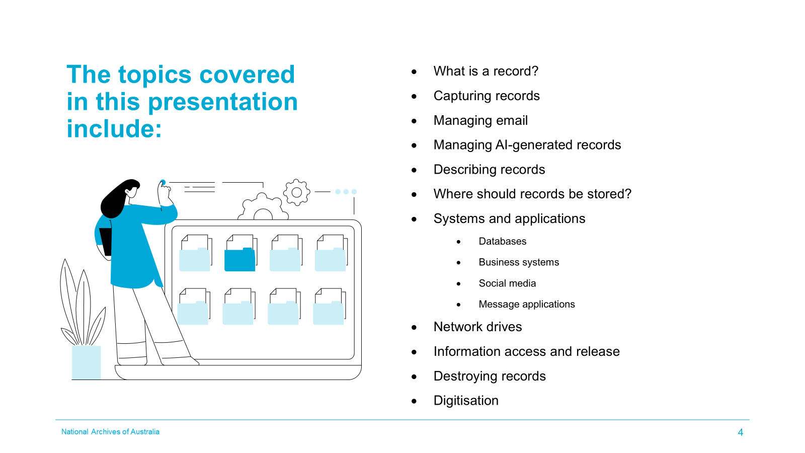
Presenter’s notes
Optional Discussion
This is an opportunity to create discussion and canvas answers from the group - use of a white board is recommended.
Ask participants what they know about information management and recordkeeping practices within the agency. Revisit answers in slide 17.

Slide 5 - What is a record?
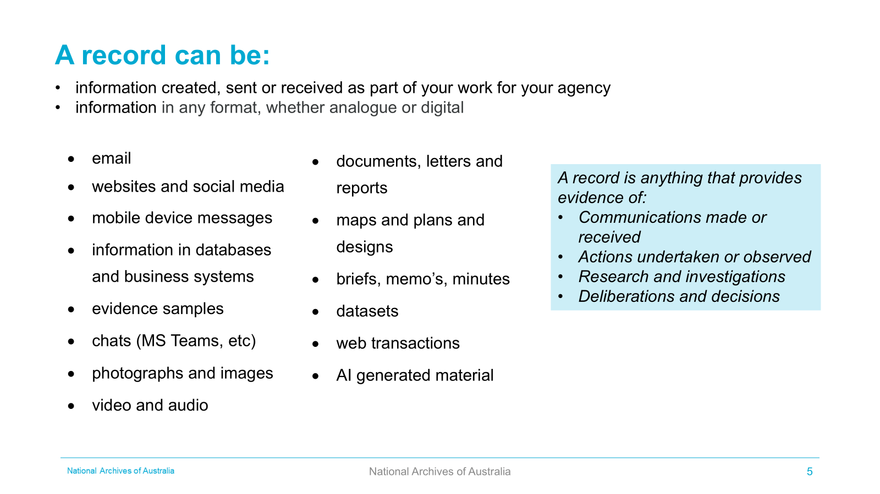
Presenter’s notes
Information created or received in connection with Australian Government business, are Commonwealth records and must be managed in accordance with the Archives Act 1983. The format does not matter but the content does.
Optional Discussion
This is an opportunity to create discussion and canvas answers from the group - use of a white board is recommended.
Whether something is a record or not depends on the information and the context - basically, if it is related to the business of your agency then it is a record.

For example, an email to the First Assistant Secretary briefing them on a topical issue is a record, whereas an email to the First Assistant Secretary letting her know her car window has been left open is not a record.

Records come in paper, electronic and other formats including letters, reports, email, information in business systems, databases, datasets, website pages, messaging, social media posts and images in photographs, film, video, audio, and DVD. Records can also be AI generated.

Individual items can be a record, but records are best when they provide context to an activity or process. Generally, records, data and information is grouped together (aggregated) to tell the story.

Depending on what business is being carried out records can also be objects like blood, air or water samples, DNA evidence, seizures for police evidence, and geological samples.

With government business now conducted digitally, electronic records such as email, documents, spreadsheets and presentations, financial transactions and online messaging have become central to our work.
Databases/datasets can exist as discrete records or may rely on a business information system to function as a ‘system of record’.
Ask what records participants make in the course of their work.
- What records are electronic? (Examples: email, messaging, databases, websites, financial transactions, metadata, human resource management system records)
- What records are on paper? (Examples: signed contracts, final or annual reports, signed letters) (Note - most records since 2016 now exist in digital format)
- What records are images? (Examples: video, maps, pictures, photographs, surveillance film, social media posts, posters)
- What records are objects? (Examples: samples, evidence, historical items).
Include specific kinds of records your agency makes or keeps.
For more information
- Principle 2: Necessary business information is created | naa.gov.au

Slide 6 - Capturing records
5 - Topic 2.0 - Managing Records
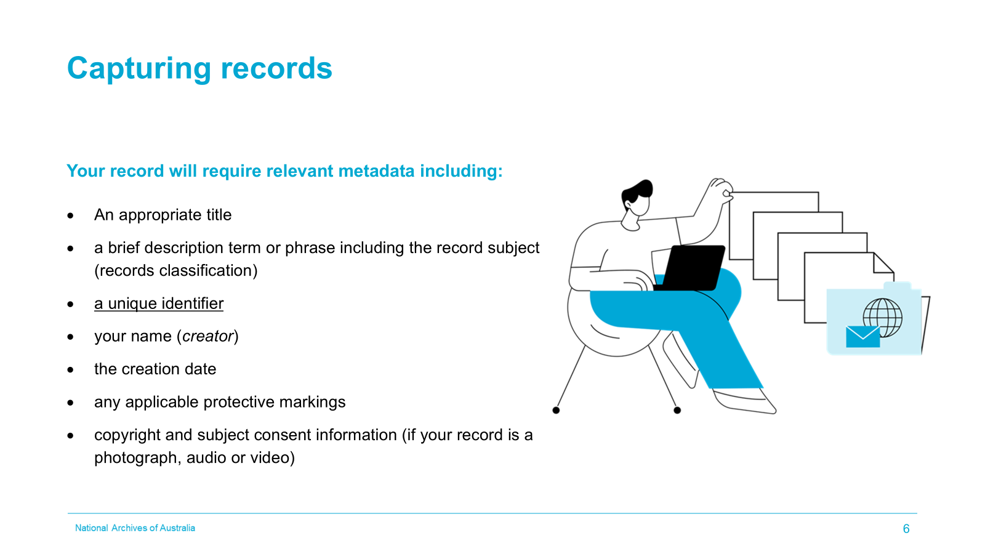
Presenter’s notes
When capturing records in [insert your agency approved recordkeeping or equivalent] or other business system, there is information about the record that needs to be captured for finding and managing the record.
This information is called metadata. Some of the metadata is auto captured by the system and other metadata is manually entered.

In [insert your agency approved recordkeeping system], the mandatory metadata is [insert your mandatory metadata such as title and any other fields that need to be manually entered when registering items in the agency approved recordkeeping system].

For more information
- Capturing information | naa.gov.au
- Principle 3: Business information is adequately described | naa.gov.au
- Meta... what? Metadata! (youtube.com)
- What's in a name? (youtube.com)
Optional discussion
This is an opportunity to create discussion and canvas answers from the group - use of a white board is recommended.
Discuss which systems are used to keep records and if not the approved recordkeeping system, highlight that some routine administrative task records made must be captured in the approved recordkeeping system.
Discuss what metadata looks like in your system

Slide 7 - Email - Managing emails as business records
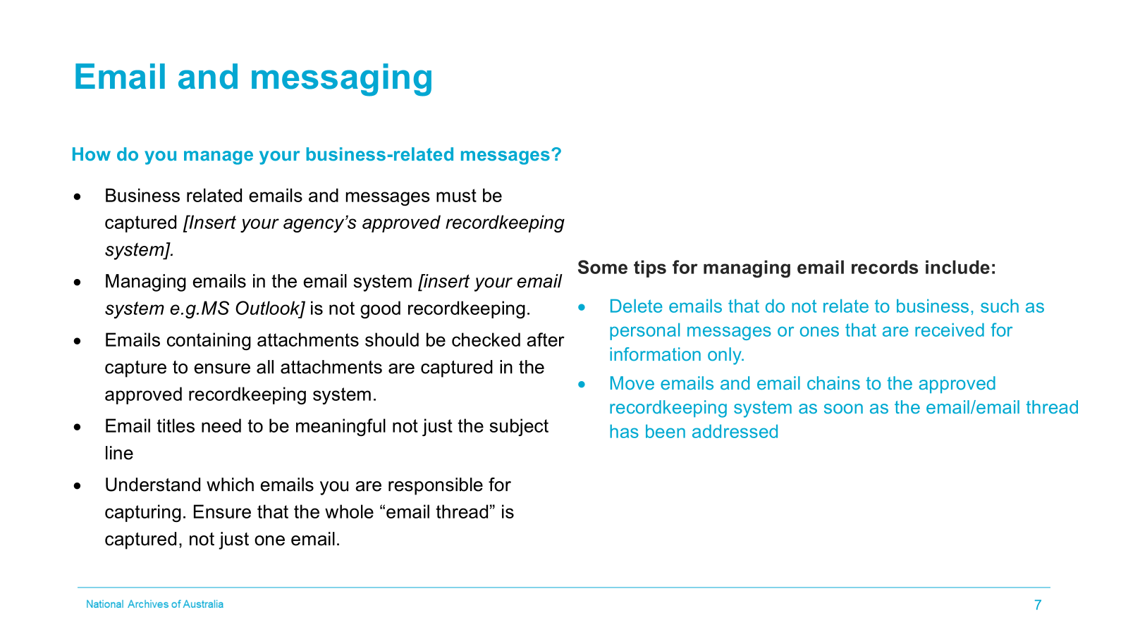
Presenter’s notes
A lot of government business is conducted by email. These messages must be captured and managed like any other record. Emails proliferate quickly and have unique characteristics that require consideration on how to best handle them as records. Most of issues associated with email could be applied. Many of these same challenges also apply to other messaging tools.

Email threads and messages sent to multiple recipients can make it difficult to decide when an email should be captured, and who is responsible. When retaining an email, always ensure any attachments are also saved so the full context of business activities is preserved.

Questions to ask include:
- Did I receive or send this email in the course of my work?
- Does this relate to a project I am working on?
- Does the email approve an action?
- Does the email provide advice, provide evidence, give a direction, or record a decision?

If you answer 'yes' to any of these questions, you need to capture the email into [insert your agency approved recordkeeping or equivalent] or other approved business system.
Things to consider when saving emails and business messages:
- Does your email contain an important attachment?
- Has the complete email chain been saved to ensure all discussion is recorded?
- Has the final email (with decision, approval or outcome) been retained?
Email that may not need to be saved into another system, and can be disposed of at any time under Normal Administrative Practice include:
- Messages received for information only.
- Trivial information such as meeting reminders and room bookings.
- Copies of information already in a records management system
- Copies of documents for reference purposes only
- General notices to staff.
Include your agency’s specific processes for the capture of emails. If it is automatically captured advise how and what is captured.
Include specific locations endorsed by your agency for the capture of email, for example saving in an EDRMS.
For more information
- Managing email | naa.gov.au
- Managing email (youtube.com)
- Normal administrative practice (NAP) | naa.gov.au
Optional discussion
- Who is responsible for capturing email - is it the sender or the receiver?
- When should an email thread be captured?
- Can emails that are received ‘for information only’ be deleted as a normal administrative practice?
- How are email attachments safely retained?
- Has the complete email chain been saved to ensure all discussion is recorded?
- Has the final email (with decision, approval or outcome) been retained separately?
- Does an email chain reliably reflect all messages in the thread?
- Can the content of email chains can be changed

Slide 8 - Managing AI Generated Records:
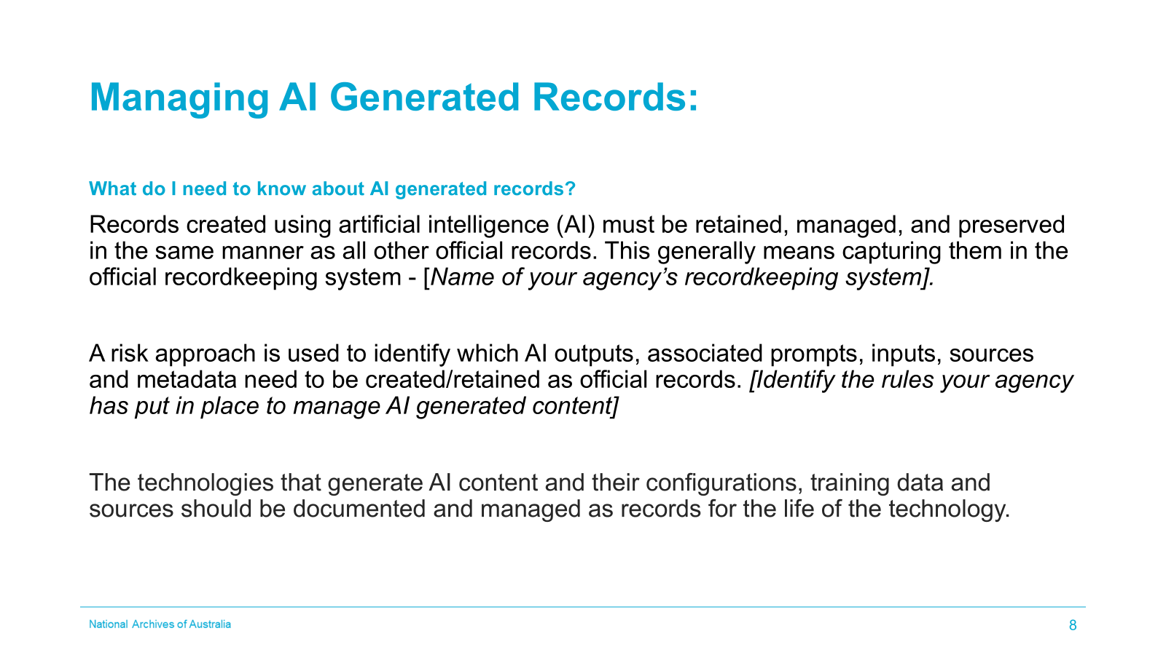
Presenter’s notes
Update the slide with your agency’s official recordkeeping system.
Update slide with your agency’s specific processes for AI generated content. Identify, which if any, AI technologies that are authorised for use and any requirements to retain prompts, inputs and data provenance. Also identify any metadata around AI usage that needs to be captured.
Records created using artificial intelligence (AI) must be retained, managed, and preserved in the same manner as all other official records. This usually means capturing them in [insert name of official recordkeeping system(s)].

Where AI has been used to assist with summarisation, drafting and for ideas, you need to [insert your agency’s requirements]. Where content is generated automatically such as [insert AI technology/system] you need to [insert your agency’s requirements].

When implementing AI technologies, you need to ensure that all the system configuration including training data for the model(s), sources for the output and anything else that may be required to justify the content generated by the AI technology.
For more information
- Information management for records created using Artificial Intelligence (AI) technologies | naa.gov.au
- Policy for the responsible use of AI in government - Version 2.0 | digital.gov.au

Slide 9 - Where and how should records be stored?
HOW SHOULD YOU KEEP RECORDS?
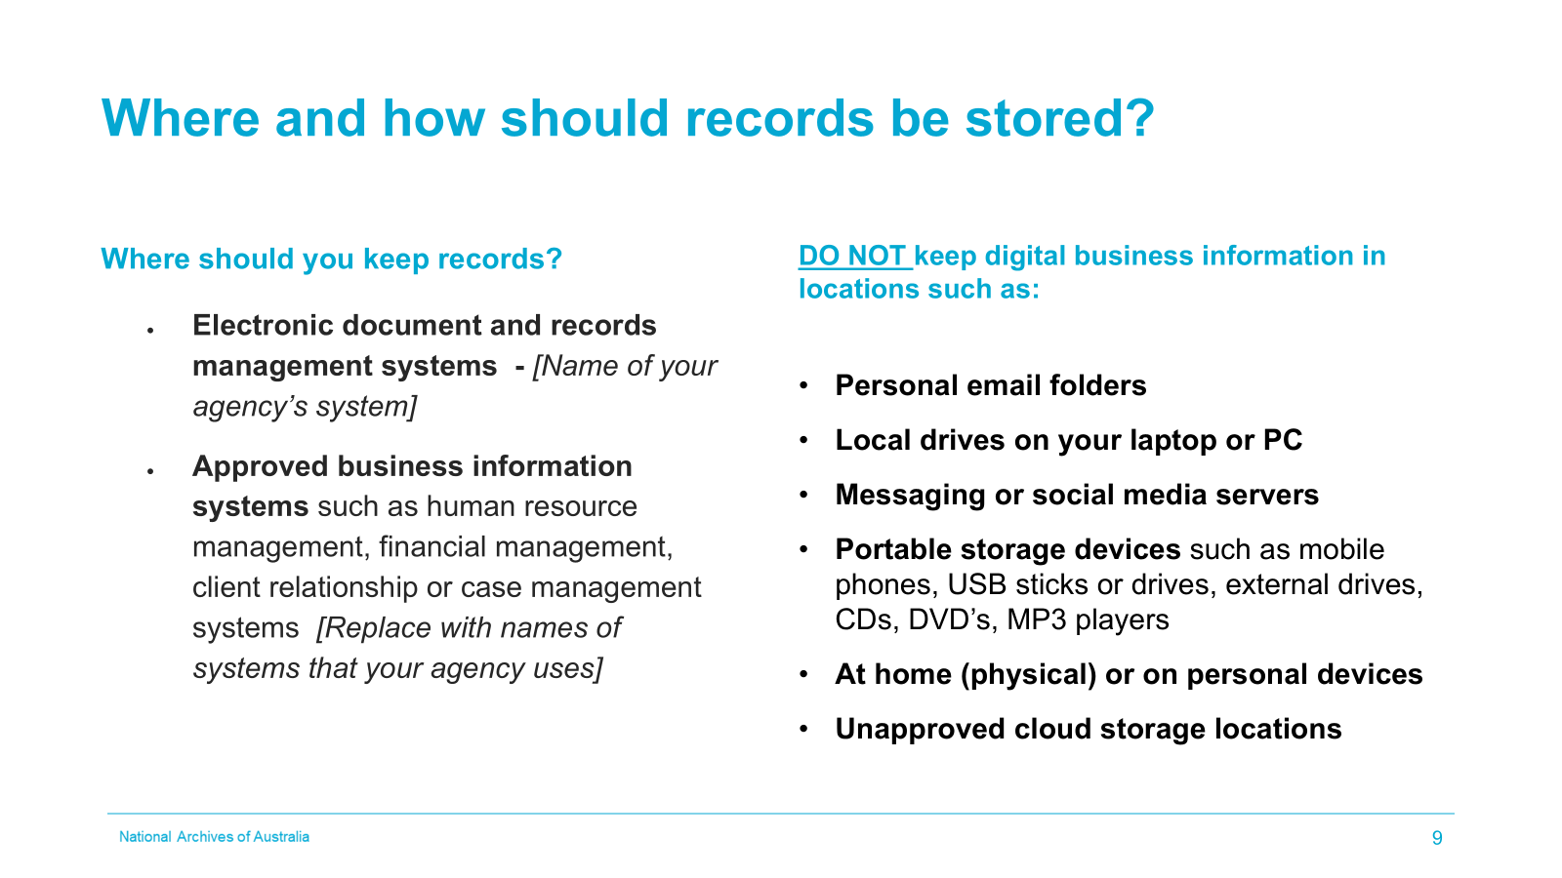
Presenter’s notes
Change the slide to include the names of the corporate locations your agency endorses for keeping records.
The following systems are endorsed recordkeeping locations for [insert agency name]:
- [Name of] Electronic document and records management systems (EDRMS) or agency approved recordkeeping system
- [Names of] Business information systems (finance, human resource management, client relationship and case management systems)
- Legacy physical records. [Where are they located? E.g. Offsite storage, basement]
Records contain information we all need to conduct our work, so it is important that they are accessible within the agency.
For more information
- Storing information | naa.gov.au
- Business System Assessment Framework | naa.gov.au
- ISO 16175 – what you need to know | naa.gov.au
- Electronic document and records management systems | naa.gov.au
Optional discussion
Discuss the various locations and why they are used, or why they should not be used and what the risks could be.
Ask participants to list the inappropriate places where records have been lost or found:
- Records being accessed inappropriately often hits the headlines such as
folders containing sensitive government documents being left in cafes or taxis.
- Walking in the street with classified records visible and able to be photographed.
- Working on a government laptop in a public place where the screen can be photographed
- USB sticks found where they are least expected with private details of individuals still stored on them.
You could use a current media example to illustrate the key message of ensuring records are not accessed inappropriately.
Mention any other locations where records might be kept which poses a risk to your agency and what the mitigation of that risk might be.

Slide 10 - Describing records
HOW SHOULD YOU KEEP RECORDS?
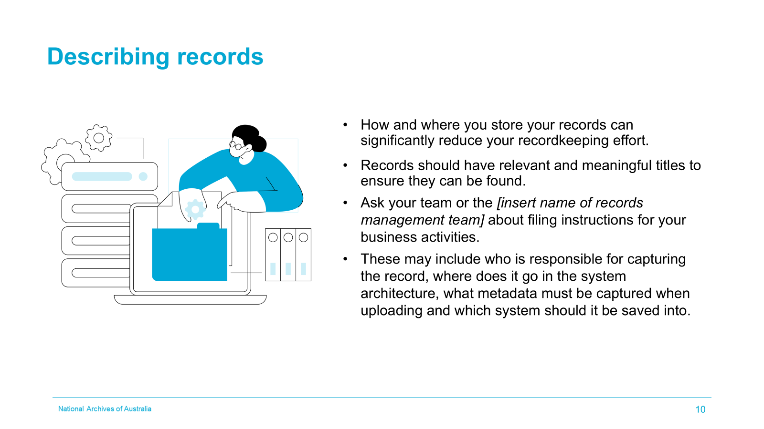
Presenter’s notes
Update slide to include your agency’s records management team name. Remove the slide if you do not currently manage your records in authorised business systems
How and where you store your digital information can significantly reduce your recordkeeping responsibilities.
- For example, if you save to the appropriate section of your EDRMS, the records will be auto-classified and the relevant disposal sentence applied.
- For example, if you select your Business Classification Scheme (BCS) from a list, the relevant disposal sentence is applied.
This is a good opportunity to talk about how information is classified in your agency.
If not already discussed, discuss titling dos and don’ts.
For more information
- Classifying information | naa.gov.au

Optional discussion
- Where do you save your records?
- What information (metadata) do you capture?
- Titling conventions – what are the requirements?

Slide 11 - Systems and applications where I work
Databases and Line-of-business information systems
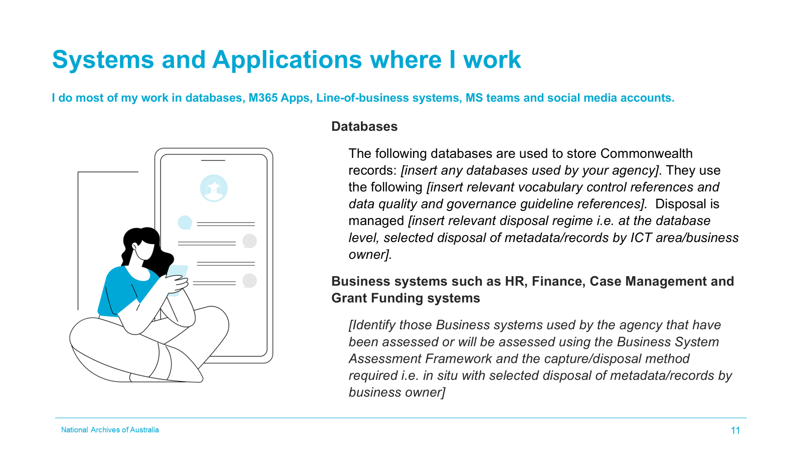
Presenter’s notes
Remove any content from this and the next slide that is not applicable to your agency.
Update slide to include the following if they are relevant to your audience:
• The names of your database(s)
• Any vocabulary controls (glossaries, thesauri, data dictionaries)
• Data quality and governance guidance
• Disposal regime
If any of these items are not relevant, remove the database section or the specific elements that do not apply
- Databases can exist as discreet records or may rely on a business information system to function as a ‘system of record’.
- Effective recordkeeping practice for databases may require use of a suitable data dictionary, approved keyword list and relevant thesauri.
Update slide to include your agency’s business system(s) name(s) if relevant, if not relevant delete the section about line-of business systems from the slide
Examples of business systems include payroll, grants management, project management or service portals. These could be configured in several different ways, as a COTS product, as-a-service offering, or could rely on systems in other categories – such as a Teams environment or bespoke database to function.
Update comments below to include your agency’s business system(s) name(s) if relevant, and the assessment and controls for the records in the system. Delete the sections that are not relevant to your agency.
- The value of information within them can vary, depending on the significance of the business activity they support. [Name of system] has records that are [temporary short-term/temporary long-term/permanent] and these need to be managed [insert management regime]
- [Name of system] is a fit-for-purpose approved recordkeeping system that allows information to be stored in situ.
For more information
- Data governance and management | naa.gov.au.
- Retaining, managing and disposing of data and datasets | naa.gov.au;
- Business System Assessment Framework | naa.gov.au
Optional discussion
What specific business information systems and databases does your agency operate?

Slide 12 - Systems and applications where I work
Social media and messaging systems such as MS Teams
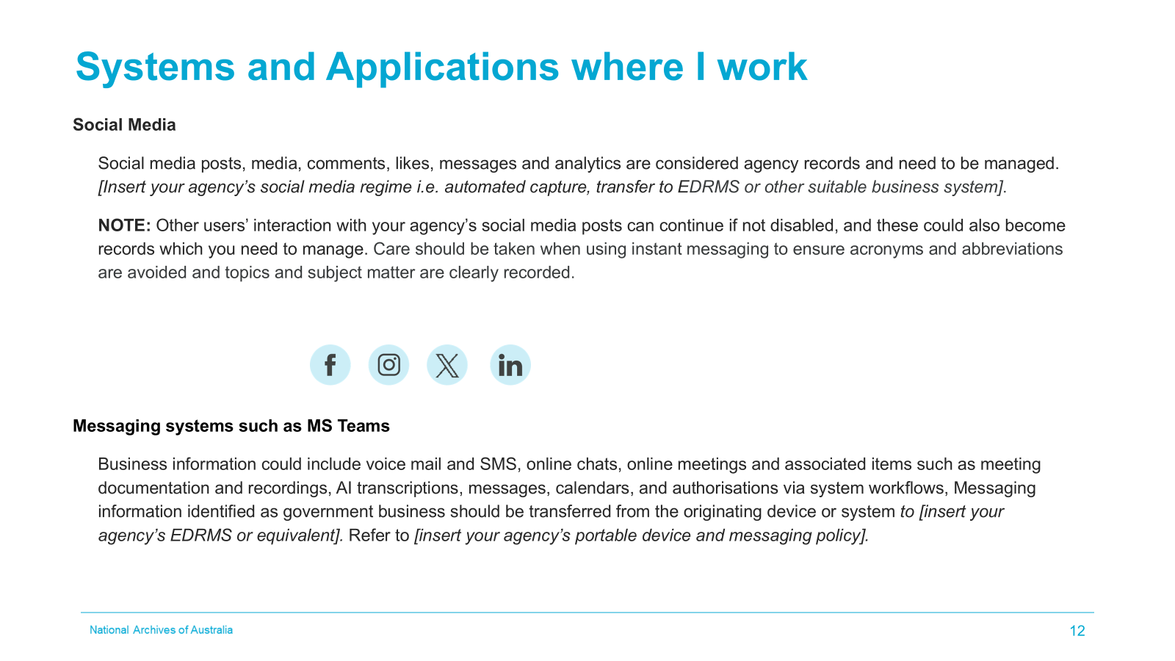
Presenter’s notes
Update slide with your agency’s advice for managing social media. Identify if it is automated capture or whether a tool is required to capture it and upload it to a business system or agency approved recordkeeping system. If you don’t have a process yet, suggest temporary storage of social media records on a network drive as an interim solution.
To be accountable, your agency must also manage its social media records. The social media platform used by your agency is not an appropriate storage area for agency’s social media interactions.
Social media posts, messaging, media, comments, messages, and analytics that are created or received as part of Australian Government business are Commonwealth records.
The use of social media and instant messaging platforms by [insert agency name] carries risks. Our [insert agency social media policy name] is an important tool to reduce risk by making staff aware of their responsibilities.
Update slide with your agency’s approved recordkeeping system and your agency’s Portable device and messaging policy or an equivalent policy. If you don’t have a policy delete the last sentence. Where possible, provide advice about how your agency manages any business information created in these systems.
For more information
- Your social media policy - what about records? | naa.gov.au
- Managing social media and instant messaging (IM) | naa.gov.au
- Security Tips for Social Media and Messaging Apps | Cyber.gov.au
- Managing information on mobile devices | naa.gov.au

Optional discussion
Name the social media platforms used in your agency and discuss how the content is or should be saved

Slide 13 - Network (shared) drives
- 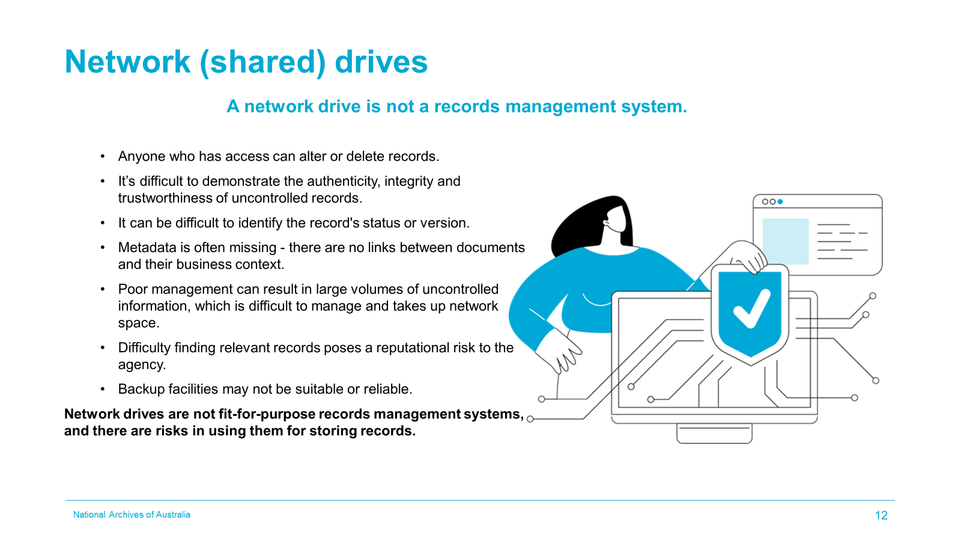
Presenter’s notes
If you use network drives because you do not have an EDRMS or equivalent update this slide and talk about how you mitigate the risks of using a network drive for your agency’s records. E.g. naming controls and defined folder structures.
If you use network drives for specific categories of records because of size or usage constraints highlight those specific requirements here.
Network drives can't manage information and records to meet Australian Government or international standards.
Unless there is a compelling reason otherwise, business information should be stored and managed in approved recordkeeping systems.
There are many risks to storing records and information on networks drives.
Omit the sentence below if your agency has an approved recordkeeping system that it uses.
However, network drives can be a temporary solution before an agency implements an electronic document records management system (EDRMS) or approved recordkeeping system.
For more information
- Network drives | naa.gov.au
- Examples of network folder structures | naa.gov.au

Slide 14 - Sensitivity and access
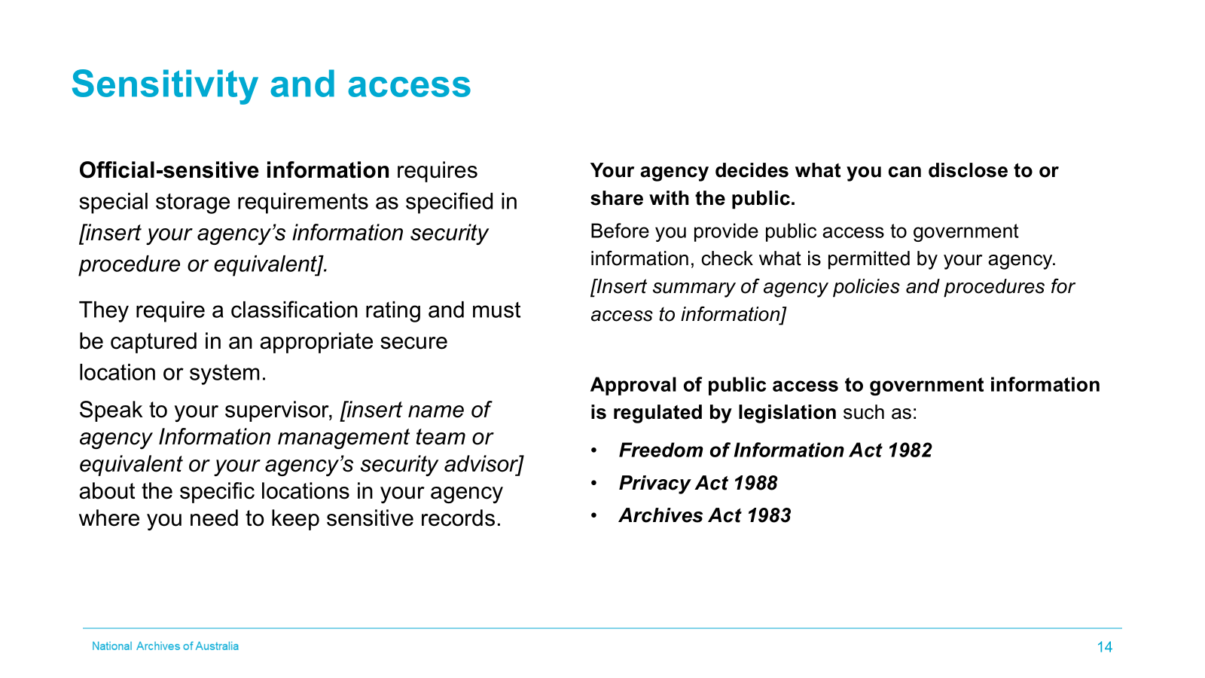
Presenter’s notes
Most agency records should be unrestricted to staff unless they contain sensitive or classified information. This includes:
- Information collected by or supplied to the agency containing sensitive information (examples include certain commercial, legal, and staffing information)
- Operational requirements (example: ‘read only’ access to stop changes to an approved record being made).
Records that need to be protected for these reasons must be labeled with the appropriate classification and stored where access can be appropriately restricted.
Mention the procedures employed for access to records in your agency, or who to ask for advice if they are unsure about disclosing information in the course of their work.

Provide examples of records that need restricted access in your agency.
Explain when and how to restrict access, for example, applying access controls in your EDRMS or business system.
Ask participants what classifications they are aware of?
- The Australian Government uses four security classifications: OFFICIAL: Sensitive, PROTECTED, SECRET and TOP SECRET. The relevant security classification is based on the likely damage resulting from compromise of the information’s confidentiality.
- All other information from business operations and services requires a routine level of protection and is treated as OFFICIAL. Information that does not form part of official duty is treated as UNOFFICIAL. OFFICIAL and UNOFFICIAL are not security classifications and are not mandatory markings.
- Caveats are a warning that the information has special protections in addition to those indicated by the security classification of PROTECTED or higher (or in the case of the NATIONAL CABINET caveat, OFFICIAL: Sensitive or higher).
- Caveats are not classifications and must appear with an appropriate security classification of PROTECTED or higher (or in the case of the NATIONAL CABINET caveat, OFFICIAL: Sensitive or higher).
Discuss when and how they should be used based on your agency’s security protocols.
As an Australian Government employee, you need to be aware of when and how access to public information can be provided.
Under the Crimes Act 1914, you must not give or disclose, directly or indirectly, any information about government or public business or anything of which you have official knowledge except in the course of your duties, or with your agency head’s express authority.
There are certain procedures that need to be followed to provide public access to records under legislation:
- Freedom of Information Act 1982: provides public access to documents through a formal application process.
- Archives Act 1983: provides public access to records more than 20 years old, also through a formal application process.
- Privacy Act 1988: sets out the safeguards Australian Government agencies must observe when collecting, storing, using, and disclosing personal information.
For more information
- Information Publication Scheme | OAIC
- When to use the Freedom of Information, Archives and Privacy Acts | naa.gov.au
- Access to records under the Archives Act | naa.gov.au
- Information management legislation | naa.gov.au
- Protecting information | naa.gov.au
- Protective Security Policy Framework | Dept for Home Affairs
- Information Security Manual (ISM) | Cyber.gov.au

Slide 15 - Digitisation

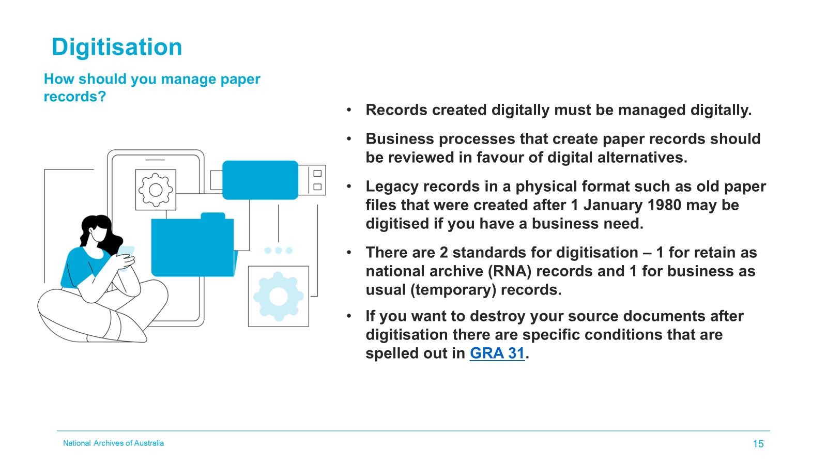
Presenter’s notes
Talk about any non-digital processes in your agency. Detail how physical records are managed in your agency and any digitisation that occurs. Who does it and how they do it.
Some processes that deal with external people may include receiving documents in physical format. For ease of management these records can be digitised and managed digitally.
If the records you are digitising are of permanent value, they will require different treatment to temporary records.
Records of permanent value are those that have either:
- Been identified as RNA (retain as national archives) in a current record’s authority.
- Been identified for permanent retention by the agency.
RNA digitisation should always be undertaken at preservation digitisation standards.
PDF is not an approved format for preservation digitisation of paper or photographic formats/records.
Discuss if staff in your agency can digitally scan records received in paper format to compliant standards for ‘business as usual’ records using departmental Multi-Function Devices (MFD) or what other alternatives may be available e.g. contact the information management team who have scanning capabilities or digitisation section if your agency has one.
If business processes are still creating paper, they should be reviewed in favour of digital alternatives.
Please consult with your information management team for appropriate standards for use in digitisation projects.
For more information
- Preservation Digitisation Standards | naa.gov.au;
- Digitisation specifications for paper records in agencies | naa.gov.au
- General Records Authority 31 | naa.gov.au
- Advice on using General Records Authority 31 (GRA 31) to support digitisation | naa.gov.au

Slide 16 - Can I destroy or delete records?
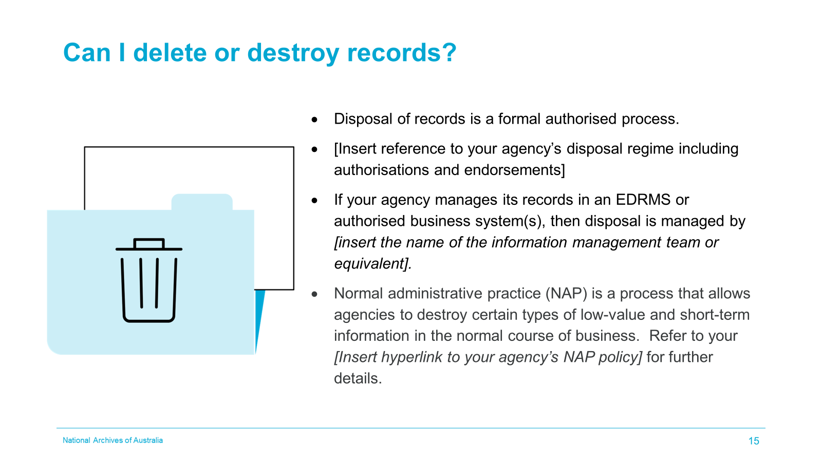
Presenter’s notes
Update point 2 with a summary of your agency’s disposal regime from an end-user perspective i.e. what do they need to do/know. Disposal may be organised by your information management team or equivalent with the business endorsing a decision that the information is no longer required, or it could be that each business area does their own disposal with authorisation given by the CEO or equivalent, or their delegate.
Update point 3 with your agency’s approved recordkeeping system or business system name and the disposal process i.e managed by the Information Management team/ICT team. If your agency is not doing electronic disposal currently, omit dot point 3
Update point 4 with your agency’s NAP policy. If your agency does not have a NAP policy yet, omit dot point 4.
Depending on your agency’s disposal process you may wish to omit portions of the presenter’s notes e.g. Information management team manages disposal so you may wish to skim over the section on records authorities.
The National Archives authorises the disposal of Commonwealth records for the purposes of the Archives Act 1983 by issuing agency-specific Records Authority (RAs) and General Records Authorities (GRAs).
We/the [insert name of information management team or equivalent] can destroy records using:
If your agency allows staff to arrange their own destruction use “we” but if it is an information management function use name of information management team.
- Our agency-specific records authority/ies [insert name/s of Agency’s approved Records Authority/ies]
- AFDA Express version 2 for the destruction and transfer of records relating to the administrative functions performed by Australian Government agencies. This general records authority covers 15 common administrative functions. Examples include financial management, personnel management, procurement, ICT, and work health and safety.
- GRAs for the destruction or transfer of records of some common business activities, such as accredited training, grant management, outsourcing, scanning of original records, advisory bodies, etc.
If your agency does not allow staff to arrange their own destruction preface dot point below with Staff can destroy certain types of low-value and short-term information during normal business.
- Our NAP policy for the destruction of low-value information, duplicates, externally published material, and unofficial information.
When records are eligible for destruction or transfer to National Archives, the following things need to be checked:
- It is not subject to a records disposal freeze
- There is no current or known impending legal proceeding or inquiry it relates to
- It does not apply to a current access application under the Freedom of Information Act 1982, the Privacy Act 1988 or the Archives Act 1983
- Business use has ceased including secondary uses
Destruction must be approved by [insert relevant approving authority for your agency]
For more information
- Disposing of information | naa.gov.au
- Normal administrative practice (NAP) | naa.gov.au
- NAP policy template
- How we select national archives | naa.gov.au
- Compliant destruction of Australian Government information | naa.gov.au

Slide 17 - Records management advice and support
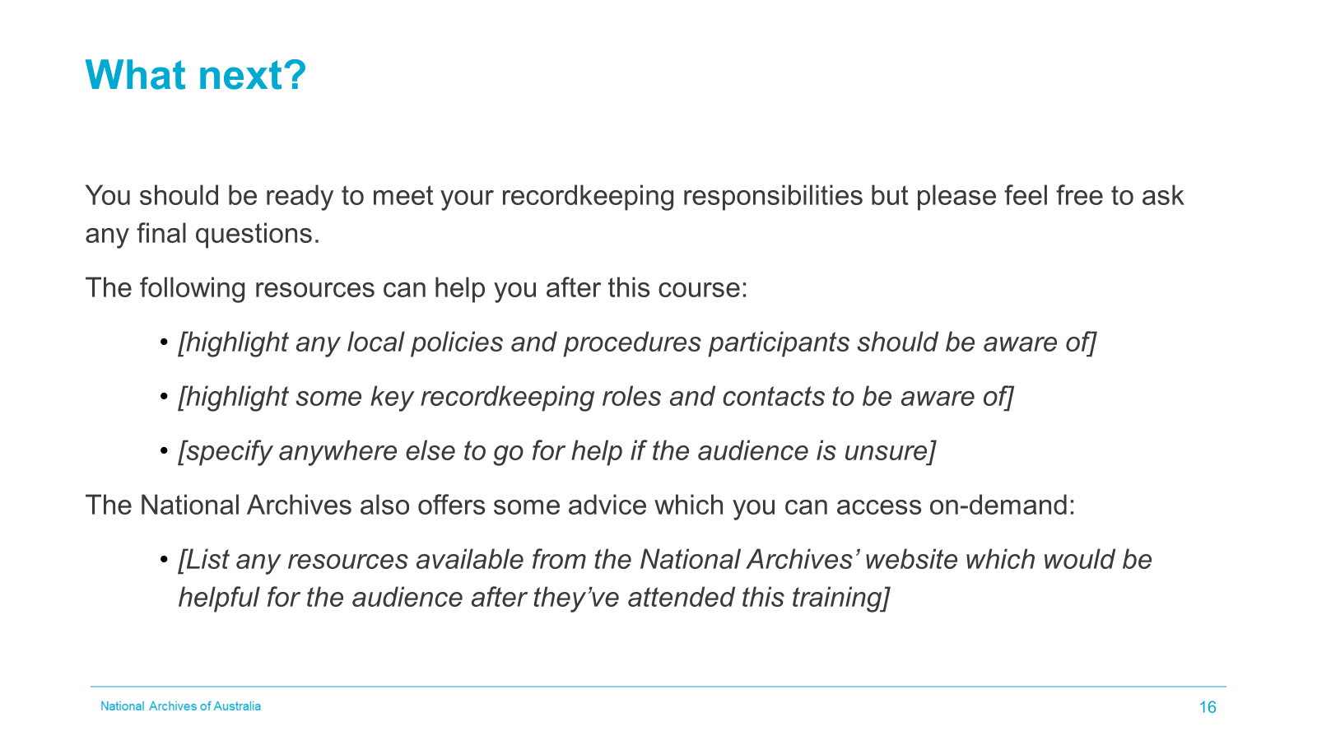

Thank you for your time today. We hope this course helped understand your recordkeeping responsibilities, but please feel free to ask any final questions.
Take this opportunity to discuss issues raised throughout the training and agree whether any out of session follow-up action would be helpful.
The following resources are available in our agency to help you after this course:
Edit the slide to list any key resources within your agency you want to bring attention to, considering:
- Local policies and procedures participants should be aware of]
- Roles and contacts, such as your local information, data or records management team or local information champions within business units.
- Local recordkeeping helpdesk or similar service, if available.
The National Archives also offers some advice which you can access on-demand.
Highlight any resources you’d recommend the audience accesses in their own time after the training:
As summary resources, you could recommend:
- Training resources
- The National Archives’ Information Management Standard
- Managing Information assets
Or you could highlight key resources within these sources or reiterate resources from earlier within this course which would best help with the issues relevant to the audience.
You can also suggest the National Archives’ Agency Service Centre unless your local recordkeeping support team would prefer to answer queries in the first instance.

Slide 18 - Acknowledging National Archives of Australia
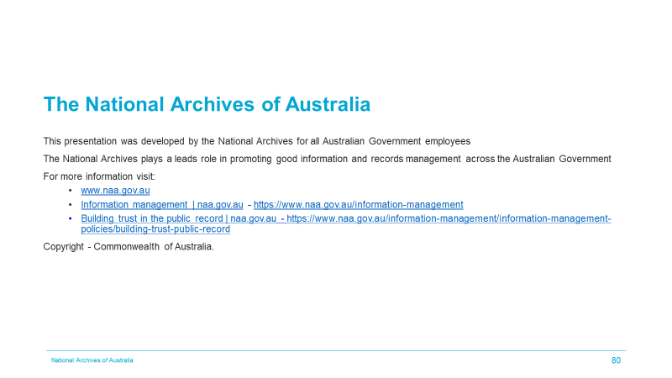
If you would like further information on what the National Archives does, please visit www.naa.gov.au.
Copyright - National Archives of Australia 2024
If you modify or adapt the presentation, amend the first point on the above slide and presenter’s notes to acknowledge that your presentation includes information developed by the National Archives of Australia for all Australian Government employees.
The rest of the information on the slide should be presented as it is, acknowledging the National Archives.

Slide 19 - National Archives of Australia

