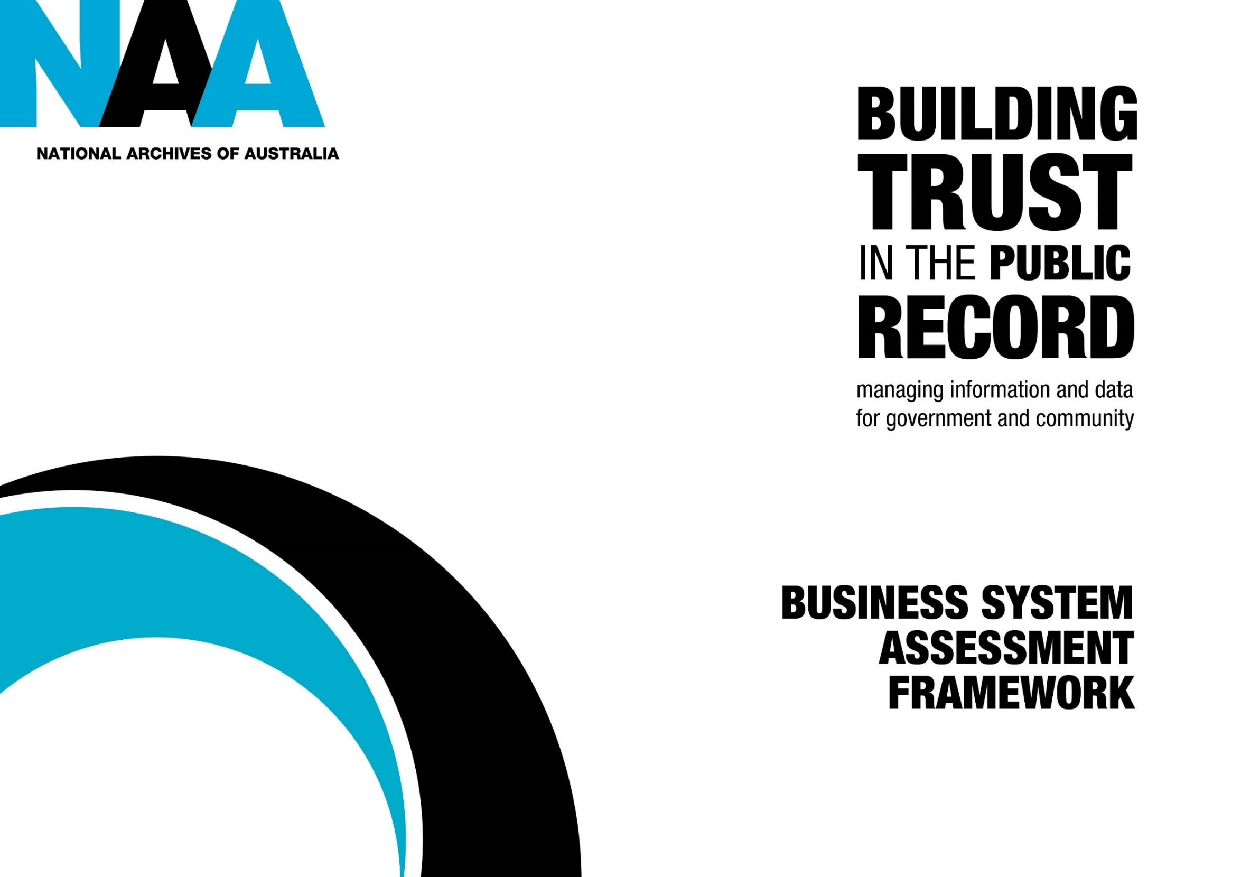
What is the Business System Assessment Framework (BSAF)?
BSAF is an assessment tool for information management functionality in business systems. It uses a risk-based approach. The framework will help your agency to better manage its records by:
- identifying risks and business requirements
- assessing the value of information and data
- identifying records in business systems guided by records authorities
- determining the functionality a system needs to manage records
- providing suggested solutions to address system gaps.
Note: the terms records, information and data are interchangeable in this framework.
When and how to use BSAF
- Use the framework to help develop functional specifications when procuring or designing new systems.
- Apply BSAF to existing systems to assess their information management functionality.
- Consider building BSAF into your information governance processes so you have a consistent way to conduct assessments.
- Set triggers for reviewing BSAF assessments, such as major technical, business, or legal changes.
- Establish fixed review dates for each system, with the frequency based on the value and risk of the records the system holds.
Further actions
- Consider amending the assessment below to suit your business needs, language and environment. For example, you may wish to amend Phase 1 Preliminary checklist for business areas with language that makes sense to the business area.
- Document your actions and responses in your system information management plan.
- Refer to the BSAF webpage for more detailed advice on governance and related processes that will assist you with your BSAF assessments.
Roles and responsibilities
BSAF is suitable for use by information management practitioners, business owners and Information Technology (IT) staff. You may also need to engage legal or risk advisors to complete your assessment.

Role | Responsibility
Business owner | Provides context about system use, its importance, the value and risk of information. Business owners should lead Phase 1 or as a minimum be consulted.
Information manager or officer | Coordinates BSAF assessment and leads Phase 2. Advises on recordkeeping, value, risk, and compliance.
IT/technical specialist | Advises on system capabilities, limitations. Assists with decommissioning and in Phase 3 - Implementing solutions.
Legal or risk advisors (if needed) | Provides input on disposal risks, compliance obligations, or reputational impacts.

Phase 1: Preliminary checklist for business areas
Phase 1 determines the need for a full assessment based on the risk and value of records in the system. It also determines if there is sufficient business benefit to manage disposal within the system.
Phase 1 is intended to be sent out to business areas for completion, with guidance from information managers.
Instructions:
Answer 'Yes' or 'No' and follow the suggested action.
No. | Question | Considerations | (Y/N) | Action for ‘Yes’ responses | Action for ‘No’ responses
1.1 | Does the system hold unique records that are not stored or managed elsewhere? | Does the system hold the only source of the records ie, is the system the only place the records exist?  Examples of non-unique records:  - ICT backups  - Email that are routinely saved to an EDRMS  - Duplicate sources of case or transaction data |  | Document the unique records this system holds. | Document the type of records and where the master version is held.
1.2 | Does the system contain records that are:  - the authoritative source of truth  - relied on to create authoritative records, or  - feeding into a system that holds the authoritative version? | What is the authoritative source?  The agreed source of records to be shared within your agency that is deemed reliable and trustworthy.  Consider:  - Are the records relied on for legal, operational, or strategic decisions?  - If the record is the only source of record in the Australian Government jurisdiction e.g., copies of information from another jurisdiction held by Australian Government agencies.  Examples of authoritative sources include:  - financial management system  - payroll system  - contract management system. |  | Document what makes the records authoritative and how it’s used or shared. | If No (and Q1.1 was also No):  Conclusion: The system likely holds low-value, low-risk records.  Action:  - Document rationale and outcome.  - Document where the authoritative source is held.  No further assessment required unless reassessed due to organisational change.

No. | Question | Considerations |  |  | (Y/N) |  | Action for ‘Yes’ responses |  |  | Action for ‘No’ responses
1.3 | Does the system contain any high-value or high-risk records? | Your system needs to have relevant controls to minimise risk and protect high value records. Examples of high-risk and high-value records include:  - vital records  - records likely to be subject to FOI, ANAO audits etc  - sensitive personal, financial, culturally sensitive records  - records used to inform AI or automation that may affect individuals or policy outcomes  - high-value datasets that are reused across multiple systems or agencies  - records of Retain as national archives (RNA) status  - unsentenced records  - long term temporary value records. |  |  |  |  | Document the details of the identified risk/value and any relevant controls (e.g. access restrictions, audit trails, metadata). |  |  | Document your justification, including the outcome of any relevant risk assessment.
1.4 | Does the system need to meet business or legal obligations within the system before decommissioning? | Consider:  - Legal or policy requirements to destroy information within a certain timeframe.  - RNA transfers to NAA.  - Any risks identified in a Privacy impact assessment (where it contains personal information). Risks will need to be mitigated before decommissioning.  - High-volume, short-term retention data (e.g., finance, HR, transactional).  - Whether some records must be retained longer than the system’s operational life.  - Any risks if records are not disposed of or transferred before system shutdown.  - Systems that do not yet have disposal coverage.  - Systems holding sensitive or classified information may require built-in security controls (e.g. access permissions, encryption, audit logging) to prevent unauthorised access. |  |  |  |  | Document rationale, timeframe.  Identify if the system contains a mix of RNA and temporary records. |  |  | Note rationale for whole-of-system disposal. Identify the longest retention period applicable to the records retained by the system.
1.5 | Will records need to be accessed after system decommissioning? | Consider:  - Whether the information is still required for business, legal, accountability, or historical purposes.  - The cost/risk of keeping the system active vs exporting records.  - Format requirements and whether the receiving system can support ongoing access.  - Decline of system usability or vendor support over time. |  |  |  |  | Document minimum retention periods and long-term access requirements. |  |  | End of assessment if you have also answered “no” to 1.3 and 1.4.  Document outcome.
Phase 2: Information management functionality checklist
This phase assesses whether the system has the functionality needed to ensure records are trusted, discoverable and usable over time.
Instructions Answer 'Yes' or 'No' to every question, using the considerations column to guide your response.
Module 1 – Information is trusted and can be found
No. | Question | Considerations |  |  | (Y/N) |  | Action for ‘Yes’ responses |  |  | Action for 'No’ responses
2.1.1 | Does the system have adequate recordkeeping metadata? | Consider:  - What metadata you will need to show your records can be trusted i.e. are authentic and can be relied upon as evidence.  - The extent of metadata in the system will depend on the level of risk, intended use and significance of the records.  - How your system captures metadata so you can justify your response.  Refer to the Australian Government Recordkeeping Metadata Standard | naa.gov.au and the Minimum metadata set | naa.gov.au.  Note you may be using other metadata standards (in addition to recordkeeping metadata) for your business needs. |  |  |  |  | Document NAA’s recordkeeping metadata standards or any other metadata standards currently implemented. |  |  | Document how you plan to address this lack of functionality to prove the authenticity of records.
2.1.2 | If the system manages workflows, does it capture key events such as authorisations? | Consider:  If a workflow event involves multiple sources of records, can they be clearly linked? |  |  |  |  | Document how the system keeps records from workflows. |  |  | Document the risk and how you plan to address the gaps.
2.1.3 | Can the system identify or prevent unauthorised changes to the records? | Consider what security controls are needed for your system to avoid, detect, counteract, or minimize security risks to records or systems.  Consider the risks if you cannot:  - Access human-readable audit logs showing changes (including destruction) to content.  - Capture all relevant actions in an audit trail. |  |  |  |  | Document how you identify and prevent unauthorised changes to records. |  |  | Document how you plan to identify and prevent unauthorised changes to records.
2.1.4 | Does the system allow you to aggregate related records? | Consider:  - If the system can aggregate records such as email attachments or other types of embedded files such as images or spreadsheets.  - The risks if decisions are made based on incomplete records when additional information is available.  Note that aggregations can be represented by metadata only and may not be visible to the end user.  An example of a system that can aggregate records is a case management system. |  |  |  |  | Document how related records aggregated. |  |  | Document risks of not being able to aggregate records and whether your agency accepts the risk.
2.1.5 | Can records be located and retrieved using metadata or full-text search? | Consider:  - FOI demands  - All relevant records can be found for decision making and efficiency. |  |  |  |  | Document the capability. |  |  | Document risks of not having search functionality and whether your agency accepts the risk.
Module 2: Disposal is accountable - This module is for those situations where business needs to manage disposal within the business system.
The key functions are to:
- manage disposal at the appropriate item or aggregated level
- destroy information as required
- manage multiple disposal classes if needed.
No. | Question | Considerations |  |  | (Y/N) |  | For 'Yes' responses, |  | For ‘No’ responses
2.2.1 | Is disposal controlled, systematic and recorded? | Consider the risks if:  - you cannot prevent records being inadvertently destroyed  - you cannot manage a disposal freeze, or  - records are not disposed of in accordance with a valid records authority.  Consider if you export information to another system, how is disposal going to be managed in both new and legacy systems?  If records need to be disposed of before the system is expected to be decommissioned, it must be either exported from the system or accountably destroyed within the system. |  |  |  |  | Document the steps involved in disposing of records, how it is recorded and controlled, and what disposal authority is being used. |  | Document how you intend on controlling the disposal of records, so it is recorded and carried out in a systematic way.
2.2.2 | Where there is more than one disposal class, can the system manage the different disposal classes? | What are the minimum and maximum retention periods for the records that are held in the system? For example, a HR system manages records of varying disposal classes.  Your approach to disposal management may mean you need to import or export your records into another system or consider the cost of maintaining a system until all records are due for disposal. |  |  |  |  | Document the retention periods for the records held in the system and how you manage more than one disposal class at a time. |  | If you have more than one disposal class, document the retention periods for the records held in the system and how you plan to manage each class.
2.2.3 | Can the system manage control records? | Following destruction of records, you should permanently keep a record of what has been destroyed in case you need to defend its destruction if challenged.  Consider the risks if you:  - do not know what has been destroyed  - cannot prove whether specific records existed at a particular date  - cannot show what disposal authority you used or who approved the destruction of information. |  |  |  |  | Document how you know:  - what records have been destroyed  - when they were destroyed  - under what disposal authority was used. |  | Document how you plan on managing the systems control records in line with accountability needs, for example:  - recording what is destroyed  - when it was destroyed  - which disposal authority was used.
2.2.4 | Is or will destruction be in line with the Information Security Manual and as directed by the National Archives? | Consider Information Security Manual requirements for destroying digital media.  Also follow the National Archives advice: Compliant destruction of Australian Government information | naa.gov.au  Other policies you might need to align with include your organisation's:  - normal administrative policy (NAP)  - risk management policy, and  - information, records and data management policies. |  |  |  |  | Document how you are meeting the Information Security Manual destruction requirements and other relevant policies. |  | Document how you will align destruction with the Information Security Manual requirements and other relevant policies.
Module 3: Export/import - Export/import functionality may be a business, information or data management requirement depending on what you need to do with it over time. There may be a requirement to import long-term temporary or permanent records into a new system when the existing system is no longer supported or the cost of maintaining the system over time is significant.
No. | Question | Considerations |  |  | Y/N |  | Action for 'Yes' responses | Action for ‘No’ responses
2.3.1 | Can the system export records? | Export functionality is essential when records need to be managed beyond the original system. This becomes important in situations such as:  - software as a service (SAAS) arrangements  - machinery of government changes, or  - RNA records transfers to the National Archives.  The export should enable linked records or aggregations to remain intact e.g. relevant attachments, metadata, audit trails and structure.  Ensure:  - your export includes all the metadata you need  - checks and safeguards have been assessed prior to deleting source data (such as an integrity check), and  - your exported records can be shared. |  |  |  |  | Document how the records will be exported and what format will be used. | Document how you will be able to achieve the functionality to export records out of the system.
2.3.2 | Can the system import records? | Ensure:  - your import includes all the metadata you need  - checks and safeguards have been assessed prior to deleting source data (such as an integrity check), and  - you check whether imported records are in formats that the receiving system can manage, access, and preserve over time.  There may be a requirement to import long-term temporary or permanent records into a new system when:  - the existing system is no longer supported  - machinery of government changes occur  - the cost of maintaining a legacy system over time is significant. |  |  |  |  | Document how you import records into the system. | Document how you will achieve the functionality to import into the system.
Module 4: Reporting - This module asks if the system is capable of reporting on information and data management processes such as the number of records due for destruction on a particular date. Accurate and efficient reporting is essential for accountable information management. Most systems can generate reports. Often it is a case of configuring the systems to produce the types of reports required for a particular business need.
No. | Question |  | Considerations | Y/N |  | For 'Yes' responses |  | For ‘No’ responses
2.4.1 | Can the system generate reports on information and data management processes? |  | Accurate and efficient reporting is essential to accountable information and data management.  Consider the types of reports required such as:  - records due for destruction on a specific date  - records sentenced on a specific date  - records selected for transfer on a specific date  - records under a specific disposal class or disposal freeze  - general usage and capture of records  - access and other security related reports. |  |  | Document how the system generates reports that detail information or data management processes. |  | Document how you will meet reporting requirements.
2.4.2 | Can the system create automatic alerts in response to specific triggers? |  | Alerts when specific records are due for review, transfer or destruction would be helpful. For example, if you are implementing automated disposal. |  |  | Document how the functionality is being used. |  | Document how you will manage this lack of functionality.

Phase 3 - Implementing solutions
Instructions:
- Use this phase once you have identified gaps (“no” responses) from Phase 2.
- Each solution includes key considerations to help you decide if it is suitable.
- The solutions are presented in recommended order.
- Liaise with your IT specialists to scope a solution or a combination of solutions depending on your risk appetite, resources and business needs.
- Document your rationale in your System Information Management Plan.
Solution 1 – Build-in (enhance or configure system)
No. | When to use | Actions and considerations | Examples
3.1 | The system can be improved through configuration, modification, or vendor upgrades. | • Identify risks associated with upgrade/reconfiguration.  • Will changes capture metadata, disposal, access?  • Are vendor options available?  • Are changes sustainable (cost/support)?  Document how and when you intend to configure, modify or upgrade, including any identified risks. | Metadata functionality  - Configure metadata fields to capture additional information to support authenticity (automatically or manually).  - Configure additional metadata fields to capture file structure and record/document relationships.  - Configure additional metadata fields to capture relevant information or data.  - Configure the system to ensure that metadata is retained after record content is destroyed.  - Ensure that metadata can be exported and retained as a control record after system decommissioning.  Audit Log functionality  - Upgrade or modify the system to make audit logs available to appropriate end users.  - Configure audit logs to capture all relevant actions.  Reporting functionality  - Configure or write reports in the system that retrieve relevant data.  - Configure or upgrade the system to provide automatic alerts as required.  Disposal functionality  - Configure the system to suspend all disposal actions while disposal data is being updated.  - Configure the system to maintain disposal data.  - Embed restrictions into user-initiated disposal actions.  - Configure of modify the system so that it can manage separate disposal actions.  Export functionality  - Configure or upgrade the system to ensure that all necessary information is exported during the export/migration process.

Solution 2 – Integration
No. | When to use | Actions and considerations | Examples
3.2 | Integration with another system will address functionality gaps | • Does integration avoid duplication?  • Are there any risks of dependency?  • Will the integration align with enterprise-wide policies?  • Record structures need to be compatible with the system they being integrated with.  Document  • Which system you’ll integrate with and why.  • Specify what information will be transferred.  • Record responsibilities for managing data across systems.  • Capture risks such as dependency or data integrity issues. | • Integrate the system with another compliant information management system (e.g. EDRMS) to:  - capture audit data  - manage disposal processes  - use reporting functionality  - use alert and digital workflow functionality  • Integrate the system with specialised or customised software applications capable of performing specific information management processes, such as disposal, classification, security or storage.  • Use Extract Transform Load (ETL) software that can convert data into the desired format to integrate with other systems.  • Use an Application Programming interface (API) to enable data integration between applications and devices to provide functionality.  • Use agreed data exchange formats and structures to allow data exchange with other systems.

Solution 3 – Export (move information elsewhere)
No. | When to use | Actions and considerations | Examples
3.3 | Records can be exported to another system for compliant management. | • Identify system receiving records.  • Capture how export will be tested/validated.  • Record mitigation strategies for loss/corruption.  • Use agreed data exchange formats (e.g. XML, CSV) to ensure information can be transferred to other systems without loss of meaning.  • Are exports automated?  • Can receiving system manage exports?  •Can you maintain additional metadata in the external system?  • Extract Transform Load (ETL) software that can convert data into the necessary formats to facilitate exporting  • Machine learning software for automated mapping of data structures to facilitate exporting data to external systems.  • Export the data periodically or as required into a format that allows you to analyse the data (i.e. a business intelligence tool, spreadsheet).  • Maintain relevant data in an external system (e.g. a spreadsheet) and make scheduled checks against the data to determine if information management actions need to be taken.  • Prior to destruction, export a full manifest of system holdings so that data indexing and search can be used to scan the system.  • Source data should not be deleted until appropriate checks and safeguards have been assessed (e.g. integrity check).  Document how you will manage the risk or gap by exporting the relevant records, so that it can be managed in a separate system. | - Export Project Documents from Collaboration tools where key documents (e.g. final reports, meeting minutes, decisions) are exported to an EDRMS.  - Export Financial Records Export from ERP Systems (Enterprise Resource Planning system).  - Records such as invoices, purchase orders, and audit trails are exported to an EDRMS.  - Export Web Content and social media posts, or digital publications to a digital archive or records management system.  - Export and maintain the required metadata in an external system (i.e. spreadsheet, compliant information management system).  - Export and maintain additional metadata in an external system (i.e. catalogues, registers, spreadsheets), that captures information and data structures and relationships.

Solution 4 – Governance (policy and procedures)
No. | When to use | Actions and considerations | Examples
3.4 | When the above solutions are not viable, risks can be managed through policy and procedures. | • Record who is accountable for oversight.  • Capture how compliance will be monitored.  • Align actions with legislative/standards requirements.  • Include in IM governance framework.  • Can rules/oversight mitigate risk?  • Are responsibilities clear across staff?  • Does your solution align with legislation/standards?  Document which business rules/ procedures need to be changed/implemented to manage risks and address gaps in the system. | • Application of a records authority where no automated control exists ie records authority disposal classes may be applied at the whole-of-system level based on the longest retention period applicable to the system content.  • Manual review of critical decisions.  • Directive on source of truth.  • Control access to the system using business rules and manual security protocols.  • Support business system policies with user training and education programs


