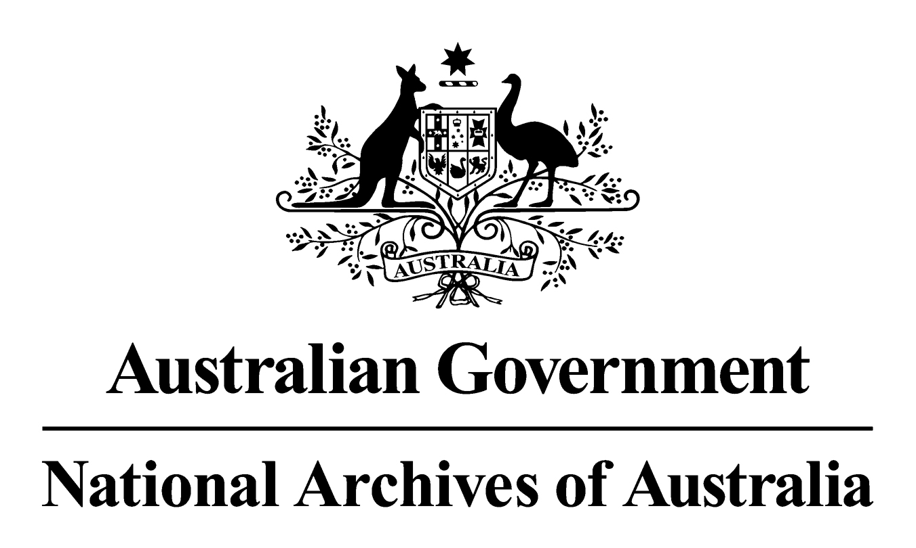

General Records Authority 33
2012/00579704

Accredited Training

February 2013

This is an accurate reproduction of the authorised records authority content, created for accessibility purposes
CONTENTS
3
3
4
5
6

© Commonwealth of Australia 2013
This work is copyright. Apart from any use as permitted under the Copyright Act 1968, no part may be reproduced by any process without prior written permission from the National Archives of Australia. Requests and inquiries concerning reproduction and rights should be directed to the Publications Manager, National Archives of Australia, PO Box 7425, Canberra Mail Centre ACT 2610, Australia.

INTRODUCTION
The National Archives of Australia has developed this Records Authority to set out the requirements for keeping or destroying the records relating to the core business of Accredited Training. The Authority is intended to have broad application for agencies that undertake an Accredited Training role as a Registered Training Provider (RTO).
This Authority is based on the identification and analysis of the business of Accredited Training. It takes into account the legal and organisational records management requirements for agencies that undertake an Accredited Training role as an RTO, and the interests of stakeholders, and the National Archives of Australia.
This Authority specifies the minimum length of time that temporary records need to be kept. This Authority gives agencies that undertake an Accredited Training role as an RTO permission under the Archives Act 1983, for the destruction of the temporary records described after the minimum retention period has expired. Retention periods for these temporary records are based on: an assessment of business needs; broader organisational accountability requirements; and community expectations.
As changes in circumstances may affect future records management requirements, the periodic review of this Authority is recommended. All amendments must be approved by the National Archives.

APPLICATION OF THIS AUTHORITY
- This Authority is to be used to determine how long records must be kept. Records are matched to the relevant core business and records class in the Authority.
- Where the minimum retention period has expired and the records are not needed for agency business they should be destroyed as authorised in this Authority.
- Records that have not reached the minimum retention period must be kept until they do.
- This Authority should be used in conjunction with Commonwealth agency specific records authorities covering the core businesses of the agency. Where there is uncertainty about which records authority to use, please contact the Archives.
- This Authority should be used in conjunction with general records authorities such as:
- the Administrative Functions Disposal Authority (AFDA) and/or AFDA Express issued by the National Archives to cover business processes and records common to Australian Government agencies;
- General Records Authority (31) For source (including original) records that have been copied, converted or migrated.
- RTOs that provide training for security or intelligence purposes must contact the National Archives prior to using this Authority. This Authority does not supersede existing coverage for ‘Accredited Training’ in current issued records authorities.
- The Normal Administrative Practice (NAP) provision of the Archives Act 1983 gives agencies permission to destroy certain records without formal authorisation. This usually occurs where records are duplicated, facilitative or for short-term use only. NAP does not replace arrangements agreed to in this Authority but can be used as a tool to assist in identifying records for destruction together with an agency's Records Authority or Authorities, and with AFDA and AFDA Express. The National Archives recommends that agencies develop and implement a Normal Administrative Practice policy. Advice and guidance on destroying records as a normal administrative practice and on how to develop an agency NAP policy is available from the National Archives' website at www.naa.gov.au
- Records that are reasonably likely to be needed as evidence in a current or future judicial proceeding or are subject to a request for access under the Archives Act 1983, the Freedom of Information Act 1982 or any other relevant Act must not be destroyed until the action has been completed.
- Records subject to a disposal freeze must not be destroyed until the freeze has been lifted. Further information about disposal freezes and whether they affect the application of this Authority is available from the National Archives website at www.naa.gov.au
- Where the method of recording information changes (for example from a manual system to an electronic system, or when information is migrated from one system to a new system) this Authority can still be applied, providing the records document the same core business. The information must be accessible for the period of time prescribed in this Authority. Agencies will need to maintain continuing access to the information, including digital information, for the periods prescribed in this records authority or until the information is transferred into the custody of the National Archives.
- In general, retention requirements indicate a minimum period for retention. Agencies may extend minimum retention periods if there is an administrative need to do so, without further reference to the National Archives. Where the Commonwealth agency believes that its accountability will be substantially compromised because a retention period or periods are not adequate, it should contact the National Archives for review of the retention period.
- Records in the care of agencies should be appropriately stored, managed and preserved. Agencies need to meet this obligation to ensure that the records remain authentic and accessible over time. Under Section 31 of the Archives Act 1983, access arrangements are required for records that become available for public access including those records that remain in agency custody.
- Advice on how to use this Authority is available from your agency’s records manager. If there are problems with the application of the Authority that cannot be resolved, please contact the National Archives.

CONTACT INFORMATION
For assistance with this authority or for advice on other records management matters, please contact the National Archives’ Agency Service Centre.

Queen Victoria Terrace Tel: (02) 6212 3610
Parkes ACT 2600 Fax: (02) 6212 3989
PO Box 7425 Email: recordkeeping@naa.gov.au
Canberra Mail Centre ACT 2610 Website: www.naa.gov.au

AUTHORISATION

RECORDS AUTHORITY 2012/00579704
Person to whom notice of authorisation is given: | Heads of Commonwealth Institutions under the Archives Act 1983 responsible for the records of Accredited Training

Purpose: | Authorises arrangements for the disposal of records in accordance with Section 24(2)(b) of the Archives Act 1983
Application: | Records relating to Accredited Training.

This authority gives permission for the destruction or retention of the records described. This authority will apply only with the consent of the agency responsible for the business documented in the records described.
Authorised by: Date of issue:
David Fricker 26 February 2013
Director-General
National Archives of Australia

ACCREDITED TRAINING
The core business of developing and delivering accredited training, as a registered training provider (RTO), to internal and external participants.
The core tasks associated with accredited training include:
- negotiating, establishing, managing and reviewing agreements;
- developing and implementing policies, procedures, plans, standards, guidelines and strategies;
- liaising with government and industry to manage accredited training;
- initial accreditation and ongoing management as a registered training organisation (RTO);
- planning, developing, implementing and evaluating training programs;
- enrolling trainees;
- delivering training and assessing trainees;
- results registration and notification;
- awarding of diplomas, course certificates and statements of attainment;
- managing trainee grievances and appeals,
- internal investigations into allegations of misconduct by the RTO;
- compliance with legislative and regulatory requirements;
- funding applications to federal, state or territory governments; and
- self-assessment of performance and documenting continuous improvement in accordance with registration standards;
The performance of the core business is supported by general administrative tasks such as:
- providing and receiving advice:
- arranging trips, venue and facilities hire, and catering;
- developing reports and submissions;
- planning, conducting and facilitating audits; and
- receiving and responding to general enquiries.
For the development and delivery of non-accredited training, or attendance at training delivered by external organisations, use AFDA/AFDA Express - STAFF DEVELOPMENT.
For the accredited training history and credentials of training personnel, use AFDA/AFDA Express – PERSONNEL
For financial transactions associated with fee-based training, use AFDA/AFDA Express - FINANCIAL MANAGEMENT.
For the registered training provider’s public liability insurance policy, use AFDA/AFDA Express - INDUSTRIAL RELATIONS.
For procuring the services of contractors, consultants and the purchase of goods and services, use AFDA/AFDA Express - PROCUREMENT.
For the production and distribution of agency publications, including promotional material used to promote the registered training provider, use AFDA/AFDA Express – PUBLICATION.

Class no | Description of records | Disposal action
61247 | Records documenting:  - registration and authorisation records supporting accredited training. Includes initial accreditation and re-accreditation of the registered training organisation (RTO) and or training program, including applications and certification, and supporting documents;  - assessment outcomes for accredited training courses. Includes results, qualifications, statements of attainment and certificates, transcripts/summary results, registers, and notifications;  - final high-level strategies and plans such as strategic operational training plans and continuous improvement strategies for training and assessment;  - development and implementation of accredited training standards, policies, procedures, guidelines and instructions;  - negotiation, establishment, maintenance and review of significant agreements. Includes contracts under seal or deeds and memorandums of understanding with external agencies or organisations for sharing or accessing information relating to the RTO; and  - allegations of misconduct by the RTO that lead to an internal investigation or formal enquiry, and or impact on a training program or course. Includes investigation and resolution processes for complaints made to the RTO.  Note: Some accredited training records in high risk business areas, such as training provided for security and intelligence purposes, may need to be retained as National Archives. Applicable RTO’s must contact the National Archives for agreement to use this Authority. | Destroy 30 years after action completed
61248 | Records documenting:  - RTO’s compliance with legislative and regulatory requirements and mandatory or optional standards. Includes accrediting body audit results, and records of breaches, grievances or appeals;  - advice to regulatory bodies, such as that relating to changes to the structure or status of the RTO. Includes the discontinuance of, or significant changes relating to, an accredited training course;  - evaluation of potential or existing training programs and services, including consultation with industry;  - successful funding applications made by the RTO to federal, state or territory governments;  - negotiation, establishment, maintenance and review of routine operational agreements relating to the RTO;  - final versions of formal internal and external reports such as training statistical reports and self-assessment reports;  - completed trainee assessment items such as written assignments, where there has been a grievance or appeal; and  - enrolment of students into a training program or course, including enrolment forms and student identification documents and recognition of prior learning. | Destroy 10 years after action completed
61249 | Master set of training material for training and workshops run by the RTO. Includes:  - programs  - lecture notes  - instructional materials  - films and videos  - online modules  - supporting records | Destroy 3 years after training material is superseded
61250 | Records documenting:  - non-contractual administrative arrangements supporting the delivery of accredited training by the agency, including facility and trainer bookings, invitations, applications, reminders, confirmations, travel and catering arrangements;  - completed trainee assessment items such as written assignments, where there has been no grievance or appeal; and  - receiving and responding to low level general enquiries in relation to accredited training which require a routine/standard response, such as course enquiries. | Destroy 2 year after action completed
61251 | Records documenting:  - routine operational administrative tasks supporting the core business; and  - accredited training activities, other than those covered in classes 61247 to 61250. | Destroy 7 years after action completed

