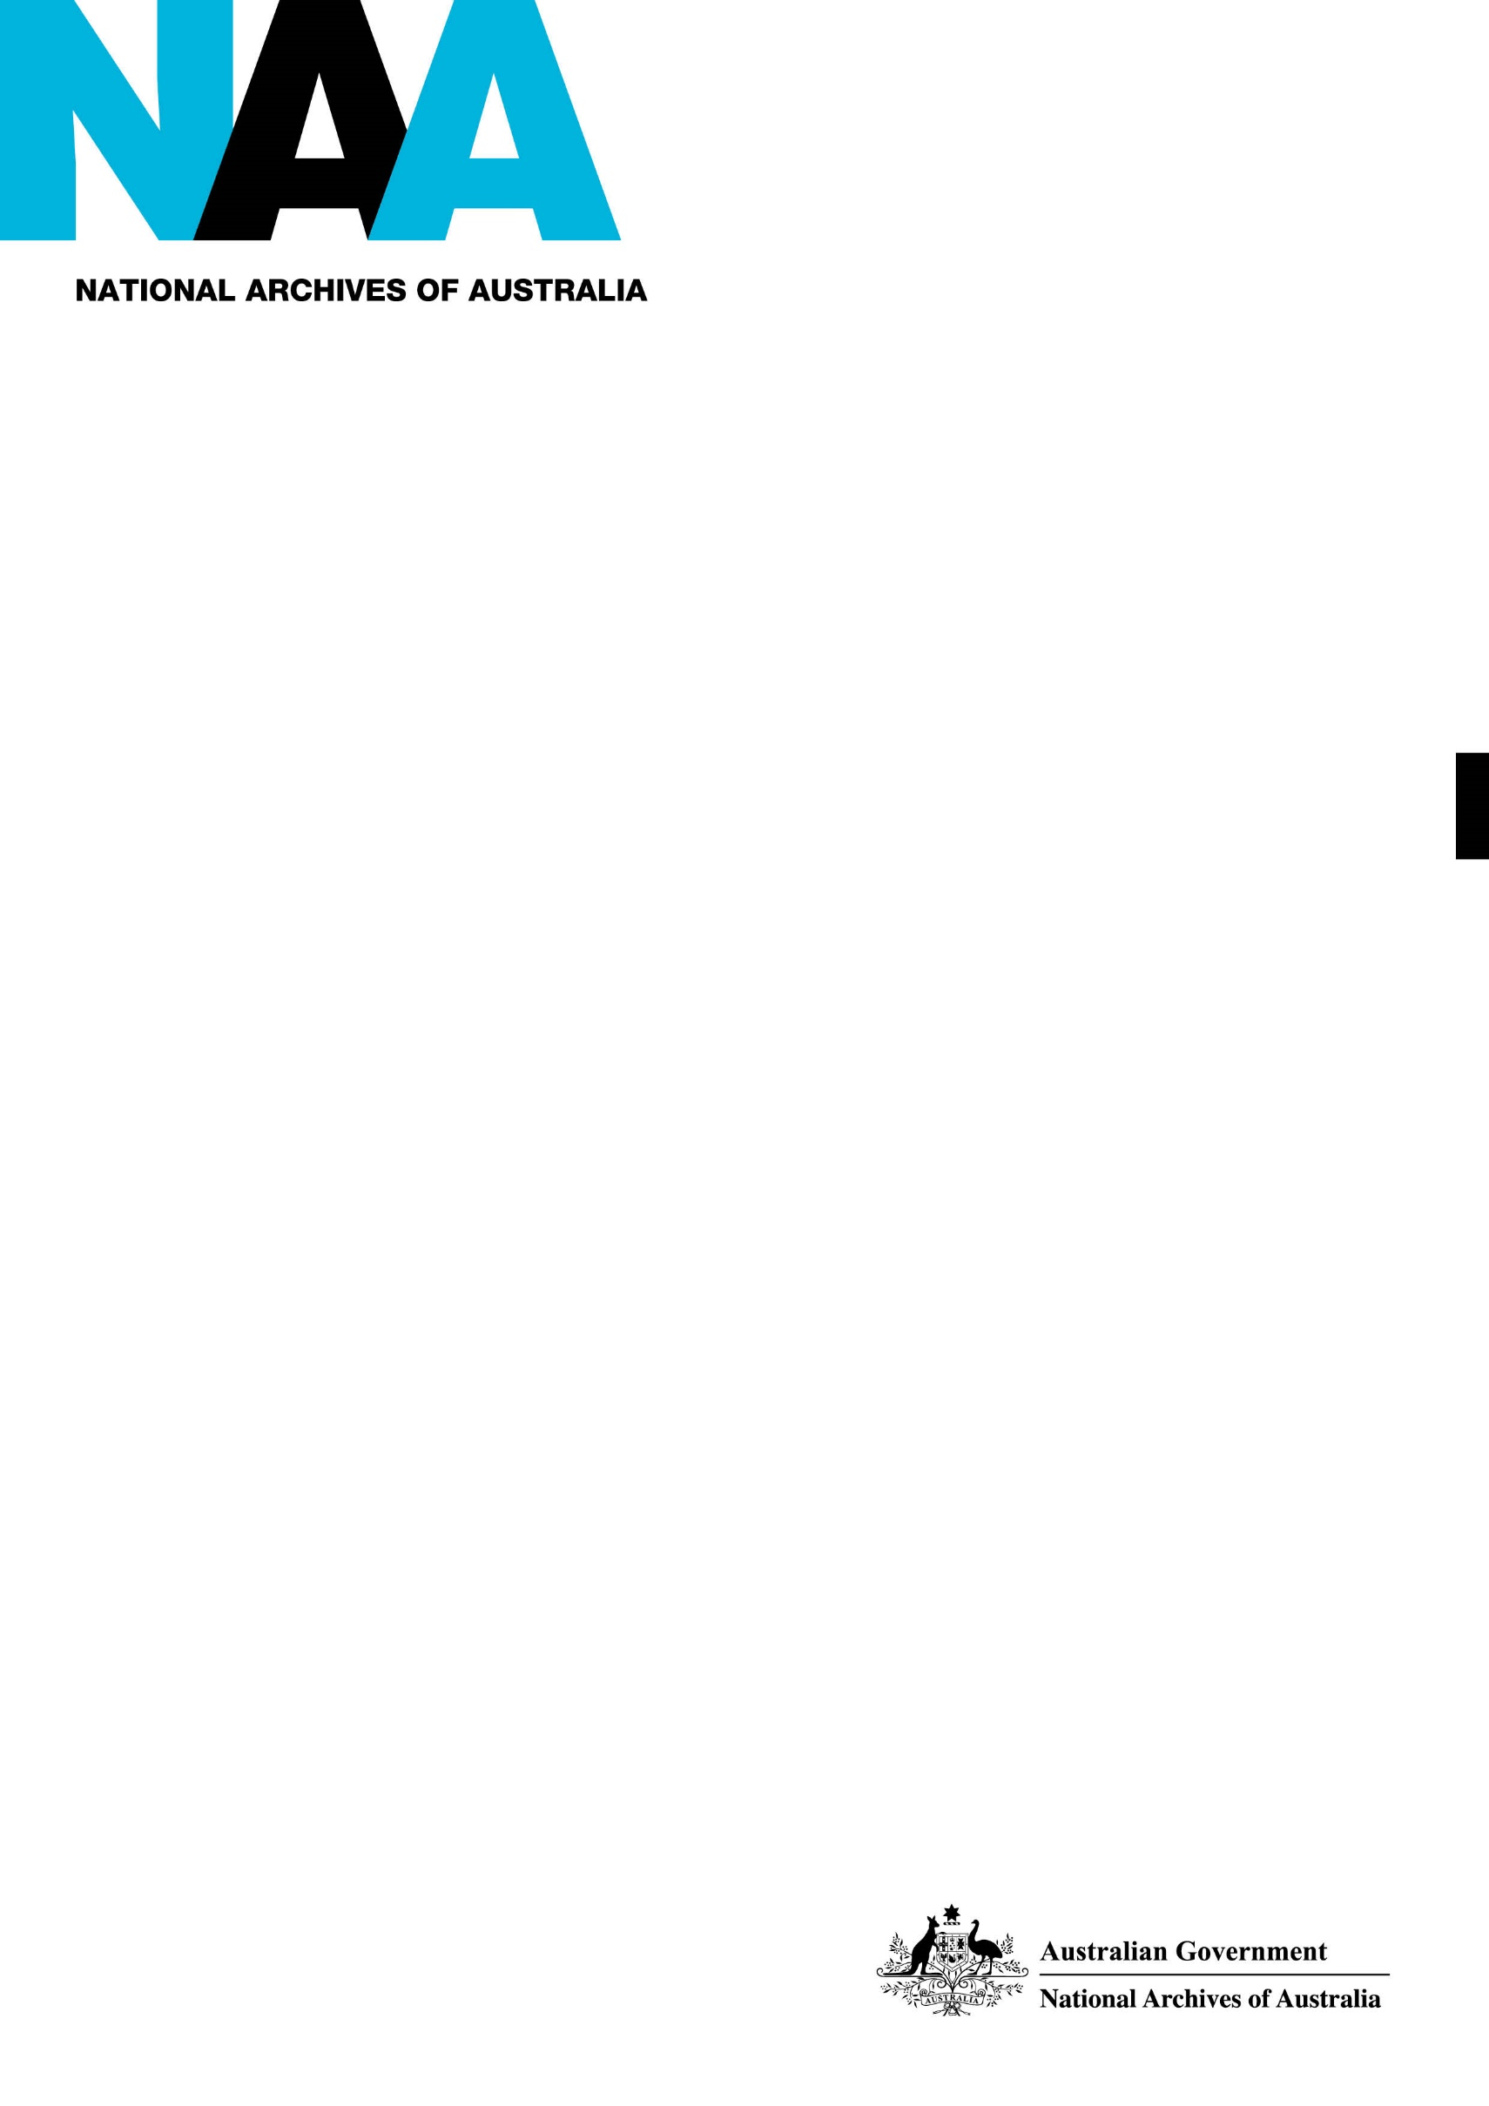

Document Control Principles

**Distributed Custody Policy**

National Archives of Australia

V 1.0

|  |  |
| --- | --- |
| **Title of Document** | **Distributed Custody Policy** |
| Version | 1 |
| Author | Strategic Initiatives and Policy |
| Document status | Final approved |
| Approval details | Executive Board, August 2015 |
| Custodian | Strategic Initiatives and Policy Section, Government Information Assurance and Policy Branch |
| Proposed review date | August 2018 |
| RkS reference | This document is stored in the National Archives of Australia Record Keeping System in file 2014/2766 as R1533392015. |

**Revision History**

|  |  |  |
| --- | --- | --- |
| **Version** | **Date** | **Comments** |
| 1.1 | August 2015 | Approved by the Executive Board |
| 1.2 | November 2015 | Edited for publication to the website |

Contents

Table of Contents

1. POLICY OUTLINE 4

2. Purpose 4

2.1 Distributed custody and the personal records collection 4

3. LEGISLATIVE BASIS 5

3.1 Policy position 5

4. SCOPE 6

4.1 Definitions 6

5. policy statement 7

5.1 Obligations under the Act 7

5.2 Distributed custody model 8

5.3 Distributed custody framework 9

6. implementation guidelines 10

7. ROLES AND RESPONSIBILITIES WITHIN THE ARCHIVES 10

8. benefits and risks 11

8.1 Benefits 11

8.2 Risks 12

9. review 13

10. authorisation 13

appendix 1 definitions 14

# POLICY OUTLINE

The policy describes the National Archives of Australia’s approach to managing Commonwealth records of continuing value that are in the custody of an organisation other than the Archives. The approach is described as a distributed custody model.

The policy applies to records of continuing value in all formats and:

* identifies obligations under the *Archives Act 1983 (*the Act) for the care and preservation of, and access to, records of continuing value;
* describes the distributed custody model supported by the Archives ;
* outlines a framework for the establishment and management of distributed custody arrangements when required; and
* specifies responsibilities of the custodial organisation and describes the role of the Archives in supporting these arrangements.

This policy provides a framework to support the long-term care and preservation of records of continuing value which are held outside the custody of the Archives.

# Purpose

The need for a clearly articulated distributed custody model to support the increasing number of digital records being held outside the Archives’ custody was identified by the Archives Digital Business Roadmap which outlines a strategic and integrated approach to the management of digital records.

Digital technologies and business processes have contributed to rapidly increasing volumes of digital information being produced and stored by Australian Government agencies. Due to the complexity of the systems storing this information, and the nature of digital records themselves, there is an increasing need for agencies to retain information beyond the period when it would normally be transferred to the Archives.

Records in both digital and physical formats may be retained by controlling agencies or housed with other organisations for a number of reasons including ongoing business needs, the need for specialist knowledge to interpret the information, or to deliver enhanced access to records. Such an arrangement is referred to as ‘distributed custody’. Custody refers to responsibility for the care of records based on their physical possession. It differs from ‘care’ which relates to responsibility for records regardless of their custody.

In a distributed custody arrangement, custody is by the organisation where the records are held, but care remains with the Archives.

## 2.1 Distributed custody and the personal records collection

Under the ‘Acquisition Policy [for] Personal Records’ the Archives collects personal records of significant individuals who serve within, or are closely associated with, the Australian Government. This policy supports obligations covered in the deed of gift arrangements with personal records donors and the transfer of custody of personal records collections.

# LEGISLATIVE BASIS

Under the Act, the Archives’ functions are to:

* select, care for, preserve and provide access to the archival resources of the Commonwealth; and
* specify records management requirements for Commonwealth government agencies.

Section 3C of the Act authorises the Director-General of the Archives to determine the ‘archival resources of the Commonwealth’, that is those records of continuing value to the Government, the Australian community and individual citizens. Section 27 provides for the transfer of records of continuing value from the controlling agency into the care of the Archives within a specified timeframe ie 15 years.

According to the Act, a record is in the care of the Archives if:

(a) the record is in the custody of the Archives; or

(b) the record is in the custody of a person in accordance with arrangements referred to in section 64.

Sections 29 and 64 of the Act support a distributed custody model, with both sections providing for records to be retained in the custody of the controlling agency. In addition, section 64 provides for records to be transferred from the Archives’ custody to the custody of an individual or an institution (which may include the controlling agency, another agency or a private institution).

Section 29 refers to records exempted from transfer to the Archives and states:

* ‘A Commonwealth institution …may … with the concurrence of the Director- General determine that a Commonwealth record…is not required to be transferred to the care of the Archives…’

Section 64 refers to custody of records and states:

* ‘..the Archives may, if the Director-General considers it appropriate to do so, make arrangements with a person for records required to be transferred to the care of the Archives, or for material of the Archives, to be kept in the custody of the person.’

In addition, Section 64(2) outlines the conditions and care arrangements that must be provided by the custodial organisation. This includes allowing regular inspections by the Archives; enabling the Archives to meet obligations under the Act such as access to records; and if required, transferring the material to the Archives.

## 3.1 Policy position

This policy supports the establishment of distributed custody arrangements under section 64 of the Act. This provides for records to be retained by the controlling agency or their agent, as well as the transfer of records from the Archives to another party. It also sets out the requirements which must be met to ensure the ongoing care and preservation of, and access to, records in a distributed custody arrangement.

# SCOPE

The Policy covers records which are:

* Commonwealth government records of continuing value; or
* other archival resources of the Commonwealth

and:

* in any format; and
* over 15 years old (in the case of an arrangement with a controlling agency); or
* of any age (in the case of an arrangement relating to personal records collections)

where they:

* are in the custody of a party other than the Archives; or
* will be transferred to the custody of a party other than the Archives

and:

* meet criteria for records suitable for custody by a party other than the Archives.

The criteria for entering into distributed custody arrangements are defined in the implementation guidelines but, in general, relate to:

* + costs of duplicating the technical environment in the archival setting;
  + changes in technology impacting on effective records management in a centralised repository;
  + skills required for managing or interpreting the records; or
  + ongoing agency need.

The policy excludes records which are of temporary value as they are not required to be transferred to the custody of the Archives. The guidance and governance provided in this policy may however be useful to agencies in the management of long-term temporary records which remain in their custody.

## 4.1 Definitions

Records of continuing value are those Commonwealth records which have been identified as ‘archival resources of the Commonwealth’ under section 3C of the Act. These records may also be referred to as records of continuing, ongoing or permanent value, or as ‘RNA’ (Retain as National Archives). This also includes other records of national significance or public interest (ie non–Commonwealth records) which have been identified as part of the archival resources of the Commonwealth, for example personal records of individuals who have held prominent positions in the Commonwealth.

Distributed custody is defined as an arrangement whereby records are managed by another party in facilities not under the control of the Archives beyond the period where they would normally be transferred to the Archives or at the request of a personal donor. It covers situations where records are retained by an agency, as well as those where the records are transferred from the Archives’ custody to a custodial organisation. The custodial organisation may be the creating or controlling agency, or other organisations such as a community or private organisation.

# policy statement

The default position as provided for under the Act is for all records assessed as being of continuing value to be transferred to the custody of the Archives.

However, in certain circumstances it may be necessary or preferable for records to remain with the controlling agency or to be transferred to another organisation. The Archives and the custodial organisation will then establish a distributed custody arrangement under section 64 of the Act.

The policy:

* identifies obligations under the Act;
* describes the distributed custody model supported by the Archives ;
* establishes a framework for the establishment and management of distributed custody arrangements when required;
* specifies responsibilities of the custodial organisation; and
* describes the role of the Archives in supporting these arrangements.

The policy applies to all distributed custody arrangements which are entered into from the date of approval of this policy, as well as to existing distributed custody arrangements as they are reviewed. It applies to records in all formats, whether physical or digital.

## 5.1 Obligations under the Act

Section 64 states that arrangements for records to be kept in the custody of an institution other than the Archives must provide for the care of that material. As defined in section 37, care includes custody, preservation and access.

### Custody

Custody relates to the requirement to keep records of continuing value safe and in conditions that support long-term preservation and access.

### Preservation

Records of continuing value must be preserved into the future. This includes protecting the records from damage or alteration.

### Access

Enabling public access to records of continuing value is essential to the objectives of the Act. Distributed custody arrangements must support access to material and provide appropriate mechanisms to enable the Archives to fulfil its access obligations under the Act.

### Inspection

Distributed custody arrangements must provide for the regular inspection of materials in the custody of others to ensure it is being properly cared for. Such inspections enable the Archives to meet its obligations under the Act and ensure conditions support access and preservation requirements.

### Other obligations

Distributed custody arrangements must not prevent the Archives from meeting its regulatory responsibilities. The terms and conditions included in each agreement will reflect this requirement.

Under a distributed custody arrangement, both the Archives and the custodial organisation have responsibilities to ensure the records are properly cared for, and obligations under the Act are met. The distributed custody model and framework below outline the responsibilities of each party to ensure these obligations can be met.

## 5.2 Distributed custody model

The Archives’ custody model is a ‘centralised model’ as defined by the Council of Australasian Archives and Records Authorities (CAARA)[1]. The centralised model means that the majority of records of continuing value are transferred to the Archives when they fall out of regular business use, or at the latest, within 15 years from the date of creation.

By exception, some records are managed under distributed custody arrangements. CAARA identifies three models for distributed custody arrangements where records of continuing value are not held by the archival authority. These are:

* Single agency (records remain with the creating agency to support business needs)
* Regional repository (records of a number of agencies are co-located in a regional area)
* Private / community organisation (usually not-for profit, non-government organisations)

The Archives current distributed custody model supports the single agency and private / community organisation models. Future adoption of a regional repository model is not excluded.

The Archives custody model provides for exceptions to be made where necessary and for arrangements for the management of records to be formally agreed upon and documented. An essential element of this model is that the Archives retains ultimate control of, and responsibility for, all records of continuing value including those not in the Archives’ custody. This also extends to the valuation of records, that is, the Archives will account for the value of records net held in its custody in its financial statements.

## 5.3 Distributed custody framework

The framework consists of six elements:

* Identifying the need for distributed custody;
* Establishing a distributed custody agreement under section 64;
* Providing guidance and support;
* Ensuring care, preservation and access;
* Monitoring and reporting; and
* Review.

Both the custodial organisation and the Archives have responsibilities in a distributed custody arrangement to ensure that obligations under the Act are met.

### 5.3.1 Custodial Organisation responsibilities

The custodial organisation is the organisation which has custody of the records. This may be the creating or controlling agency, or a third party.

* Identify records of continuing value that cannot or will not be transferred to the Archives;
* Provide justification for retaining the records;
* Enter into a formal distributed custody agreement with the Archives;
* Manage and maintain records in accordance with the Archives’ guidance and the terms and conditions of the agreement; and
* Provide access to records in accordance with the Act.

Custodial organisations which are not the controlling agency will have responsibility from the point of entering into a formal agreement.

### 5.3.2 Archives responsibilities

* Proactively engage with controlling agencies and other custodial organisations to identify circumstances which may require a distributed custody arrangement;
* Provide clear guidance for establishing and maintaining a distributed custody arrangement;
* Provide streamlined processes and templates for the establishment of arrangements under section 64;
* Provide clear guidance for the storage, access and protection of records in distributed custody; and
* Establish and maintain a cycle of review and monitoring.

Adopting a distributed custody model does not prevent the Archives from eventually accepting custody of records of continuing value (see section 64 (2) (d)). Good governance through formal arrangements supports future transfer of records as opportunities arise.

# implementation guidelines

Implementation guidelines (to be developed) support both the Archives and custodial agency procedures for managing the establishment and ongoing maintenance of distributed custody arrangements. The guidelines may also be applied to existing distributed custody arrangements as they are reviewed.

The guidelines include:

* Criteria for identifying situations where distributed custody arrangements may be required;
* Workflows and procedures for establishing distributed custody arrangements;
* Development (and maintenance) of advice and assistance to support custodial organisations in establishing and maintaining a distributed custody arrangement;
* Section 64 agreement and other templates to reflect policy requirements and provisions of the Act;
* Framework for monitoring (inspection), including timelines, frequency of visits, key reporting aspects and identification of ‘critical’ indicators that arrangements need to be revised;
* Review of existing arrangements to bring them in line with the policy framework; and
* Communication strategy to ensure key messages are clearly understood.

# ROLES AND RESPONSIBILITIES WITHIN THE ARCHIVES

The following table outlines roles and responsibilities for implementation of the distributed custody policy. The Branches listed have primary responsibility for the roles indicated, but action should be undertaken in consultation with relevant stakeholders, both internal and external.

|  |  |
| --- | --- |
| **Roles within Archives** | **Responsibilities** |
| Approval of policy | Executive Board |
| Identification of potential custodial organisations for distributed custody arrangements | Government Information Assurance and Policy (records not in Archives’ custody)  Collection Management |
| Establishment and monitoring of distributed custody arrangements | Collection Management |
| Development and maintenance of implementation guidelines and advice for custodial organisations | Collection Management |
| Ensure terms and conditions of section 64 agreement are met | Custodial organisation and the Archives (through Collection Management, and Government Information Assurance and Policy) |
| Policy review | Collection Management  Government Information Assurance and Policy |

# benefits and risks

## 8.1 Benefits

There are a number of benefits for the Archives, controlling agencies and custodial organisations, as well as the public, in a distributed custody model for records of continuing value.

Benefits for all parties in establishing a formal distributed custody arrangement include:

* streamlined processes;
* improved public access; and
* a more collaborative relationship between the Archives, controlling agencies and custodial organisations.

In addition, the expected benefits for the Archives are:

* reduced need to duplicate specialist, complex and expensive systems;
* reduced storage costs; and
* reduced preservation costs.

The expected additional benefits for custodial organisations are:

* increased ability to reuse information within the organisation; and
* creation of new business opportunities.

The expected benefits for the community include:

* enhanced access in situations where custodial organisations are better placed to interpret the records.

## 8.2 Risks

The following major risks and associated mitigation strategies have been identified for the Archives and for custodial organisations.

|  |  |
| --- | --- |
| **Major Risks** | **Mitigating Strategies** |
| Archives does not meet its obligations under the Act. | Provide custodial organisations with guidance and support to ensure proper care and preservation of, and access to, records in their custody.  Provide infrastructure to support public access to records in distributed custody arrangements (eg online finding aid such as RecordSearch).  Undertake regular monitoring of distributed custody arrangements in line with section 64 agreement. |
| Custodial agencies do not have the skills or resources to meet obligations under section 64 agreement. | Provide custodial organisations with adequate guidance and support to ensure proper care and preservation of, and access to, records in their custody.  Develop network amongst custodial organisations to support sharing of resources and skills.  Exercise rights under section 64 agreement to bring records into Archives’ custody. |
| Archives does not have sufficient resources available to undertake support and monitoring activities. | Develop standardised, streamlined arrangements (eg standard advice on website).  Develop annual plan to inspect custodial organisations in rotation.  Require head of custodial organisation to take ultimate responsibility for meeting section 64 agreement. |
| Archival resources become too dispersed. | Ensure distributed custody arrangements are only entered into according to agreed criteria.  Identify opportunities for collaboration (eg co-locating two arrangements). |
| Negative impact on Archives’ reputation due to perceived lack of relevance. | Maintain Archives’ custody as the default, and only enter into distributed custody arrangements according to agreed criteria.  Provide central access point (eg online finding aid such as RecordSearch) to records in both Archives custody and distributed custody arrangements.  Develop communication plan and a clear message for the purpose and benefits of distributed custody arrangements. |

# review

Collection Management, in consultation with Government Information Assurance and Policy, Access and Communications and other relevant internal and external stakeholders, will review this Policy every 3 years. Supporting documents will be reviewed at least every 3 years or as required.

The policy will also be evaluated at the time of review to assess whether objectives have been met.

# authorisation

This policy has been approved by:

David Fricker

Director-General

National Archives of Australia

August 2015

# appendix 1 definitions

|  |  |
| --- | --- |
| Care | Under section 37 of the *Archives Act 1983*, to care for the record is to be responsible for its safe custody and proper preservation. ‘Care’ is broader than ‘custody’ and applies to records both in the custody of the Archives and the custody of another organisation. |
| Custody | The responsibility for the care of records and archives based on their physical possession. Custody does not necessarily include legal ownership. |
| Distributed custody arrangement | Distributed custody is defined as an arrangement whereby records are managed by another party in facilities not under the control of the Archives beyond the period where they would normally be transferred to the Archives. It covers situations where records are retained by the agency, as well as those where the records are transferred from the Archives’ custody to the custody of another party. The custodial organisation may be the creating agency, or other organisation such as a community or private organisation. |
| Archival resources | ‘Archival resources of the Commonwealth’ includes Commonwealth records of continuing value as well as other records of national significance or public interest which have been identified as part of the archival resources of the Commonwealth, for example personal records of people who have held prominent positions in the Commonwealth. |
| Records of continuing value | Those Commonwealth records which have been identified as archival resources under section 3C of the Act. These records may also be referred to as records of continuing, ongoing or permanent value, or as ‘RNA’ (retain as national archives). |
| Controlling agency | The agency responsible for Commonwealth records, based on function. The controlling agency may be the same as the recording (or creating) agency, or may have inherited responsibility for the records through machinery of government changes. |
| Custodial organisation | The organisation, other than the archival institution, responsible for the care of records of continuing value managed under a distributed custody arrangement. The custodial organisation may be the controlling agency or may be a third party such as a community, non-government or private organisation. |
| Other organisations | Refers to any third party such as a community, non-government or private organisation. |

1. CAARA Policy 15 ‘Models for the distributed custody and management of government archival records’, available at http://www.caara.org.au/index.php/policy-statements/models-for-the-distributed-custody-and-management-of-government-archival-records/