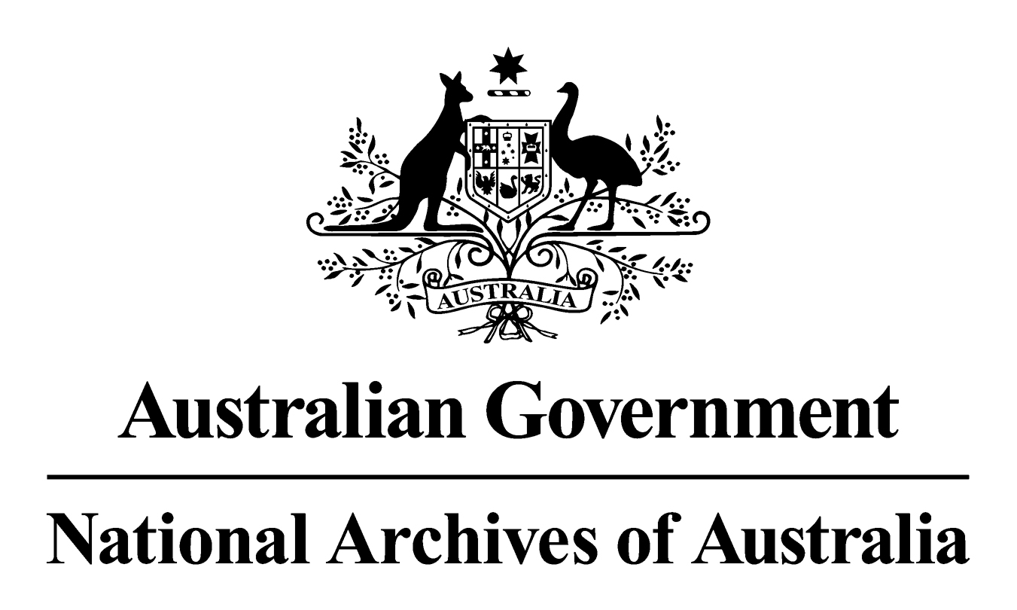

Records Authority

2011/00064423

General Records Authority No. 30
Records damaged beyond recovery in a natural disaster, a defined emergency or other unforeseen circumstance

This is an accurate reproduction of the authorised records authority content, created for accessibility purposes

February 2011

CONTENTS

INTRODUCTION 3

APPLICATION OF THIS AUTHORITY 3

CONTACT INFORMATION 4

AUTHORISATION 5

CLASSES 6

Damaged records 6
© Commonwealth of Australia 2011
This work is copyright. Apart from any use as permitted under the Copyright Act 1968, no part may be reproduced by any process without prior written permission from the National Archives of Australia. Requests and inquiries concerning reproduction and rights should be directed to the Publications Manager, National Archives of Australia, PO Box 7425, Canberra Mail Centre ACT 2610, Australia.

INTRODUCTION
The National Archives of Australia has developed this Records Authority to set out the requirements for emergency destruction of records damaged beyond recovery in a natural disaster, a defined emergency or other unforeseen circumstance.
Agencies that have records damaged in these circumstances must notify the Archives as soon as possible after the records are damaged. This authority outlines the information that agencies must provide so that the Archives are informed of the circumstances.
Records that pose a health hazard may need to be destroyed before the Archives is advised.
EXCLUSION
This authority cannot be used to account for the damage or destruction of records resulting from negligent actions or inaction by the agency.
APPLICATION OF THIS AUTHORITY
For the purposes of this authority, ‘records damaged beyond recovery’ is taken to mean that the records are still in existence but have been reduced to a state that makes their recovery impractical, uneconomic or hazardous to health or safety.
When assessing the possibility of recovering the records it is important to consider their value to the agency and as potential archival resources of the Commonwealth. A longer retention requirement strengthens the case for recovery action. If Retain as National Archives (RNA or RP) records are damaged but may still be recovered, agencies should contact the Archives before destroying the records.
The Australian Emergency Management Glossary, Manual 3, 1998, Australian Emergency Manual series defines ‘disaster’ and ‘emergency’ as follows:
Disaster
‘A serious disruption to community life which threatens or causes death or injury in that community and/or damage to property which is beyond the day-to-day capacity of the prescribed statutory authorities and which requires special mobilisation and organisation of resources other than those normally available to those authorities.’
Emergency
‘An event, actual or imminent, which endangers or threatens to endanger life, property or the environment, and which requires a significant and coordinated response.’
This includes natural, technological and human-caused events. These events are likely to include:
- significant damage to property, infrastructure, agriculture or the environment;
- or disruption to essential services, commerce or industry;
- or trauma or dislocation of the community at an estimated total cost of A$10 million or more.

Other Circumstances
Other circumstances in which records might be damaged beyond recovery include but are not limited to:
- building fires
- burst water pipes or fire suppression systems
- malicious damage
Information to be provided to the National Archives of Australia
Agencies must provide corroborative information to the Archives when using this authority. This should include:
- A description of the circumstances causing damage to the records
- A description of the scope of the records damaged - general description of what the records covered and the number or volume of records affected
- The value of records – are the records covered by a records authority? What is the expected retention period? Would the cost of recovery be justified by the value of the records?
- OH&S considerations for recovery purposes – are the records contaminated or perhaps inaccessible because of building instability
- Evidence of circumstances, damage and OH&S considerations. This may be provided in the form of reports from building inspectors, independent advice about the potential archival value of the records, OH&S or public health inspectors, or photographic records.
- A statement by the agency head or Senior Executive Service officer responsible for the records that they are aware of the circumstances and confirm that the records are beyond recovery.
- If the records have been totally destroyed in any of the circumstances described above, making the gathering of more detailed information impossible, a statement by the agency head or Senior Executive Service officer is acceptable to confirm to the Archives that the records have been destroyed.

CONTACT INFORMATION
For assistance with this authority or for advice on other records management matters, please contact National Archives’ Agency Service Centre.
Queen Victoria Terrace Tel: (02) 6212 3610
Parkes ACT 2600 Fax: (02) 6212 3989
PO Box 7425 Email: recordkeeping@naa.gov.au
Canberra Mail Centre ACT 2610 Website: www.naa.gov.au

AUTHORISATION

RECORDS AUTHORITY 2011/00064423
Person to whom notice of authorisation is given: | Heads of Commonwealth institutions under the Archives Act 1983

Purpose: | Authorises arrangements for the disposal of records in accordance with Section 24(2)(b) of the Archives Act 1983
Application: | Records damaged beyond recovery in a natural disaster, a defined emergency or other unforeseen circumstance

This authority will apply only with the consent of the agency currently responsible for the business documented in the records described.

Authorising Officer Date of issue:
Ross Gibbs
Director-General

National Archives of Australia

Class No | Description of records | Disposal action
21952 | Records damaged beyond recovery in a natural disaster, a defined emergency or other unforeseen circumstance | Destroy as soon as practicable

Exclusion:
- Excludes damage or destruction of records resulting from negligent actions or inaction by the agency.

Conditions
- Seek approval from agency head or Senior Executive Service officer responsible for the records
- Provide the National Archives of Australia details of circumstances and scope of records damaged.

