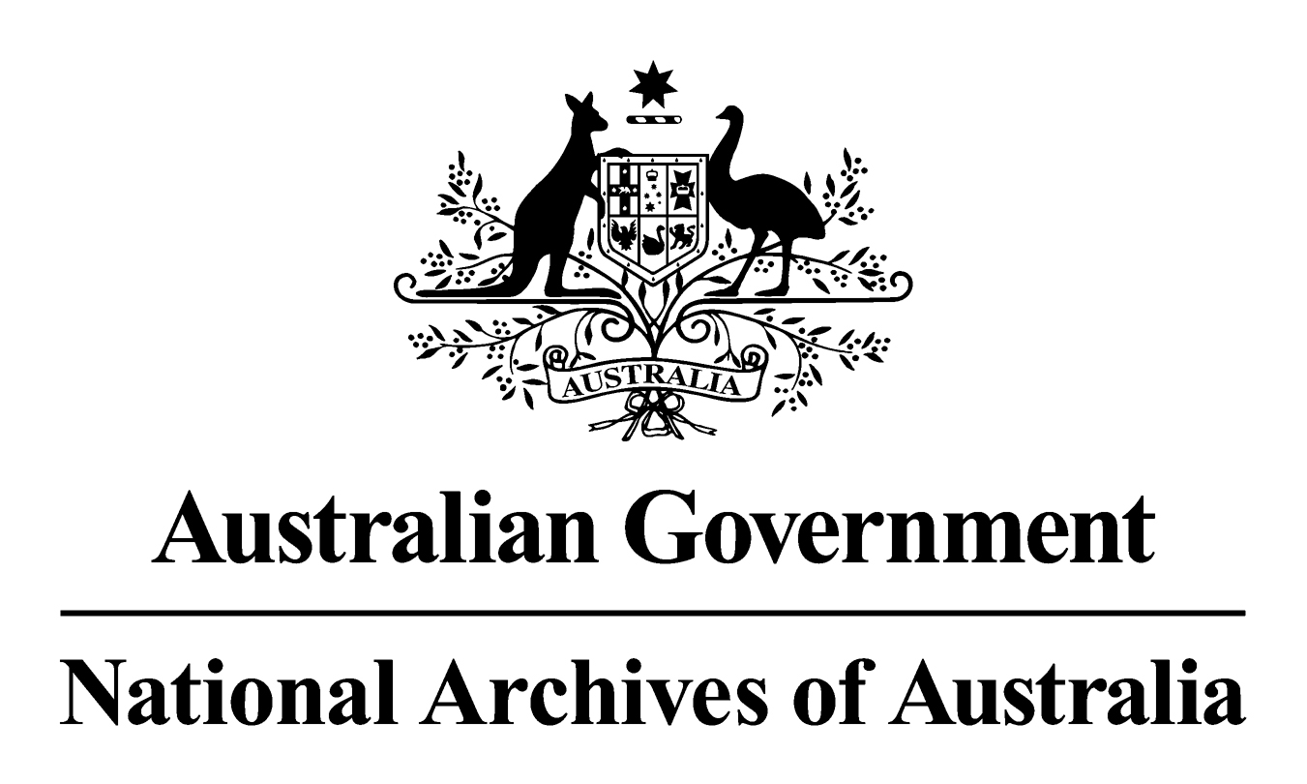

General Records Authority 40
2017/00045834

Transfer of custody of records under Australian Government outsourcing arrangements

This is an accurate reproduction of the authorised records authority content, created for accessibility purposes

2017

© Commonwealth of Australia (National Archives of Australia) 2017
Copyright
This product, excluding the National Archives of Australia logo, Commonwealth Coat of Arms or registered trademark, has been licensed under a Creative Commons Attribution-Non-Commercial (CC-BY-NC) Version 4.0 International Licence. You may share, copy, redistribute, remix, transform and build upon this work for non-commercial purposes only. However, you must attribute the National Archives of Australia as the copyright holder of the original work, include the attribution as set out below and indicate if changes were made. The full terms and conditions of this licence are available at www.creativecommons.org.
Attribution
This records authority is licenced by the Commonwealth of Australia (National Archives of Australia) under a Creative Commons Attribution-Non-Commercial (CC-BY-NC) Version 4.0 International Licence. The original version can be found on our website.
Accessibility
This is an accurate reproduction of the authorised records authority content, created for accessibility purposes.
Contact Us
Enquiries relating to copyright or accessibility should be made through the Agency Service Centre.
CONTENTS
INTRODUCTION 4
APPLICATION OF THIS AUTHORITY 4
CONTACT INFORMATION 6
AUTHORISATION 7
CLASSES 8
CONDITIONS 8
APPENDIX I: RESPONSIBILITIES IN OUTSOURCING ARRANGEMENTS 9

INTRODUCTION
The National Archives of Australia has developed this records authority to set out the requirements for the transfer of custody of Commonwealth records to contractors providing services under outsourcing arrangements, either on behalf of or to the Australian Government.
This records authority endeavours to protect the rights and entitlements of the Australian Government and its people by requiring that appropriate measures are in place before records are transferred out of Commonwealth custody. This authority takes into account legal and organisational records management requirements and the interests of stakeholders, including Australian Government agencies and the National Archives, to ensure that the archival resources of the Commonwealth are preserved and that agency obligations under the Archives Act 1983 and other legislation and business requirements are met.
As changes in circumstances may affect future records management requirements, this records authority may occasionally be amended by the addition of new classes or variation to existing classes. The National Archives will notify agencies of any such changes.
Appendix I provides additional advice on agency responsibilities in outsourcing arrangements.
Disclaimer: The advice contained in this document should only be used for general guidance. It cannot cover all possible scenarios encountered when outsourcing. You will need to investigate the issues surrounding each outsourcing instance and take appropriate action depending on the outcomes sought. You should seek specific legal advice about contractual arrangements applicable to your circumstances and the advice of your information and records management specialists.

APPLICATION OF THIS AUTHORITY
- This records authority supersedes General Disposal Authority 25 (1998). The superseded authority cannot be used after the date of issue of this authority.
- This records authority should be used in conjunction with relevant agency-specific records authorities and other general records authorities, such as:
- AFDA Express issued by the National Archives to cover business processes and records common to Australian Government agencies;
- the General Disposal Authority for encrypted records created in online security processes; and
- General Records Authority 31 – Destruction of source or original records after digitisation, conversion or migration.
- The following definitions are used in this records authority.
- custody refers to the physical possession or control of property, such as records (apart from any rights of ownership).
- contractor covers all service providers whether it is a State or Territory Government entity, private company or an individual.
- transfer of custody refers to the transfer of custody of property, such as records, to another party, with the Commonwealth retaining the ownership of that property (for example, a loan of an item).
- transfer of ownership refers to the transfer of physical, digital, legal and, in certain circumstances, intellectual property rights in records to another party.
- This records authority authorises the transfer of custody of Commonwealth records to contractors, provided the terms and conditions of the records authority are met. Only those records which are reasonably required by the contractor to fulfil their obligations should be transferred, all other records should be retained by the agency.
This records authority does not authorise the transfer of ownership of any records. If it is necessary to transfer the ownership of any original records to the contractor, please contact the National Archives for further advice.
- This records authority does not cover records involved in the sale or privatisation of a Commonwealth-owned entity. In these cases the National Archives must be contacted for the preparation of a specific records authority to cover custody and ownership under section 24(2)(b) of the Archives Act 1983.
- This records authority covers records for:
- Services provided on behalf of the Australian Government – where a contractor acting as an agent of a government agency provides a service which is that agency's responsibility (ie core business). Where a contractor provides services on behalf of the Commonwealth, then ownership (including intellectual property rights such as copyright) of existing or new records created by the contractor must be vested in the Commonwealth. These are Commonwealth records under the Archives Act 1983.
Examples include: contracting to private sector agencies for the provision of employment placement services; provision of services to veterans on behalf of the Department of Veteran's Affairs.
- Services provided to the Australian Government – usually involve ‘non-core' or administrative functions of an agency (which may have previously been undertaken in-house) or services provided to the agency itself rather than to its clients, such as the support functions of personnel, ICT or property management. Where a contractor provides services to the Commonwealth, it is not always necessary for ownership of related records to vest in the Commonwealth. This issue must be considered carefully and be directly addressed in legally-binding agreements so there is no doubt of ownership of any material resulting from the provision of services (see Appendix I for further advice).
Examples include: records management function for an agency; facilities management for properties of an agency; provision of personnel management services for an agency; and shared service arrangements between Australian Government agencies and other jurisdictions (see Appendix I for further details).
- The conditions set by this records authority ensure that obligations under the Archives Act 1983 and other legislation are met. The conditions outlining Australian Government requirements for records under government outsourcing arrangements (including those relating to ownership, intellectual property, disclosure, security, access and disposal) should be included in contractual arrangements entered into by the agency. The transfer of custody of the records is only valid if the conditions listed in the authority are met. Other conditions may be included in contractual arrangements entered into by the agency if required. It is the agency's responsibility to ensure that all conditions attached to the transfer are met.
- As well as the Archives Act 1983, other legislation such as the Privacy Act 1988, Freedom of Information Act 1982 and Crimes Act 1914 also apply to records covered by this records authority. In addition, agency-specific legislation may include requirements relating to the creation, access to or disposal of records including preserving the rights and entitlements of individuals in outsourcing arrangements.
- Records subject to a disposal freeze or that are reasonably likely to be needed as evidence in a current or future judicial proceeding, must not be destroyed until either the disposal freeze is lifted or the legal action has been resolved. While custody of these records may be transferred to contractors, adequate contractual safeguards must be put in place to ensure that the integrity and authenticity of the records is protected, including protection against unauthorised destruction while in the custody of a contractor.
- Records in the care of agencies and contractors should be appropriately stored, managed and preserved, to ensure that the records remain authentic and accessible over time. Under section 31 of the Archives Act 1983, access arrangements are required for records that become available for public access, including those that remain in the custody of an agency.
- Advice on how to use this records authority is available from your agency's information and records manager. If there are problems with the application of the records authority that cannot be resolved, please contact the National Archives.

CONTACT INFORMATION
For assistance with this authority or for advice on other information management matters, please contact National Archives’ Agency Service Centre.

AUTHORISATION

RECORDS AUTHORITY 2017/00045834
Person to whom notice of authorisation is given: | Heads of Commonwealth institutions under the Archives Act 1983

Purpose: | Authorises arrangements for the disposal of records in accordance with Section 24(2)(b) of the Archives Act 1983.
Application: | This authority permits the transfer of custody of records to contractors providing services on behalf of or to the Australian Government under outsourcing arrangements.

This authority gives permission for the destruction, retention or transfer to the National Archives of Australia of the records described. This authority will apply only with the consent of the agency currently responsible for the business documented in the records described.
Authorising Officer Date of issue:
01 August 2017
Teressa Ward
Assistant Director-General
National Archives of Australia

CLASSES
Class no | Description of records | Disposal action
62282 | Commonwealth records reasonably required by the contractor to perform its contractual obligations. | Transfer custody of records to contractor for the period of the contract provided that the conditions below are met

CONDITIONS
The agency must meet the following conditions.
- Ensure that the contractor does not destroy or otherwise dispose of records without the express permission of the agency (in accordance with records authorities issued by the National Archives).
- Recover all Commonwealth records (including Commonwealth records created during the course of the contract) at the completion or termination of the contract, or at any other reasonable time, and ensure that they are in a useable format.
- Ensure that the records are appropriately managed and maintained.
- Ensure that the security of the records is protected.
- Ensure that personal information is protected consistent with the provisions of the Privacy Act 1988.
- Ensure that unauthorised disclosure of information is prevented, in accordance with the provisions of the Crimes Act 1914 and any legislation relevant to the agency.
- The contractor provides reasonable access to the records by the agency and its authorised agents.
- Ensure that the use of the records by the contractor is limited to legitimate purposes under the terms of the outsourcing arrangement.

APPENDIX I: RESPONSIBILITIES IN OUTSOURCING ARRANGEMENTS
Australian Government agencies are responsible for ensuring that the outsourcing arrangements they enter into with contractors or other providers adequately protect the Commonwealth’s interests in both the existing records transferred to the contractor and any new records created by the contractor while performing the outsourced function.
Ownership of records created during outsourcing arrangements
Ownership of records created or maintained by contractors should be determined when preparing the outsourcing contract. All legal agreements entered into by the Australian Government for the purchase of services should clearly state the ownership (including intellectual property rights such as copyright) of any records resulting from, or maintained during, the performance of the contract. This mitigates the risk of records being unavailable through loss by unauthorised destruction or disputed ownership.
Ownership of records generally should remain with the Commonwealth. The Commonwealth should own all records that it needs to maintain accountability to the Parliament and to the people and to protect their interests, and safeguard operational efficiency.
The agency should seek to retain ownership of records where:
- the outsourced activity represents services performed on behalf of Australian Government (eg a core function or regulatory responsibility of the agency, or a service provided directly to agency clients);
- the records are required by the agency (or another contractor) after the termination of the contract to enable the service delivery to continue, or for any other reason;
- the records are used to establish the rights, entitlements or obligations of the Commonwealth or an individual; or
- the records may be used for ongoing research by the Commonwealth or an individual.
Records owned by the contractor
Some records may be owned by the contractor where it has been determined that they are not reasonably required by the Australian Government for any further purpose. These records are likely to be facilitative in nature or created while providing services to the Australian Government. For example, ‘housekeeping’ records used by the contractor to support their activities under the contract (eg contractor personnel records, financial records, intellectual property developed by the contractor prior to the current contract). Contracts should specify what sort of access to these records is needed, if any, by the Australian Government.
Factors to consider in contractual arrangements
The Australian Government’s interests in the records of outsourced functions will need to be protected by contractual means.
When developing a contract, the agency will determine which existing Commonwealth records, if any, need to be transferred to the contractor to enable the contract to be performed. The contractor will then assume the management of those records, in accordance with the records management standards prescribed by the agency in the contractual arrangement.
In some cases, it may be appropriate to retain the records in agency custody and provide access to the contractor as required. Making duplicates of relevant records (or parts of records) to transfer to the contractor is also an option. Records not required by the contractor will be retained by the agency.
To ensure the Australian Government’s interests are protected, contracts should:
- ascribe custody and/or ownership (including intellectual property rights such as copyright), either to the Australian Government or the contractor, as appropriate;
- prescribe minimum information and records management standards for Commonwealth records with which the contractor must comply – consistent with those of the contracting agency (eg covering management, storage and security);
- ensure compliance with all legislative requirements, such as the Privacy Act 1988, Freedom of Information Act 1982, other agency specific legislation or other requirements relating to confidentiality or inappropriate disclosure;

- ensure that the records are not inappropriately used or disclosed by the contractor;
- provide a mechanism to ensure reasonable access to the records by the Commonwealth, its authorised agents and the public, as appropriate;
- establish a process for the agency to recover the records at the completion of the contract, including transferring Commonwealth records created during the course of the contract;
- ensure the records recovered at the completion of the contract are in an appropriate format;
- prohibit destruction of records by the contractor except with express permission of the agency, in accordance with records authorities issued by the National Archives; and
- ensure that any subcontractors are also subject to these contractual requirements.
Agencies should seek specific legal advice to ensure that appropriate clauses are included in the contract.
Monitoring the contract
In the process of managing and monitoring the outsourcing contracts, agencies will need to create and keep appropriate records of their decisions and activities. These may include:
- records of the tender evaluation process to account for the selection of a contractor;
- minutes of meetings between the agency and the contractor;
- contract variation details;
- contract discussions, issues and resolutions; and
- reports from the contractor.
Transfer of Commonwealth records at the completion of the contract
Outsourcing contracts should cover arrangements for the termination or completion of the contract. Factors to consider include:
- identifying Commonwealth records that are required by a new contractor to ensure continuity of service (or required by the agency, if outsourcing is not to continue);
- establishing a strategy for transferring Commonwealth records to the new service provider or back to the Commonwealth, as appropriate;
- ensuring that where Commonwealth records are transferred back to the Commonwealth, the transfer occurs within a reasonable timeframe and the records are transferred in a usable and appropriate format;
- ensuring that contractors do not retain copies (duplicates) of Commonwealth records they have transferred back to the Commonwealth at the completion of the contract; and
- planning for migration of digital records to ensure continued access.
Agencies should keep details of Commonwealth records in the custody of the contractor to ensure that the records can be located if required and to ensure that all Commonwealth records are recovered at the end of the contract.
Note: The return of records to the Commonwealth, while technically a ‘transfer of custody’, does not require the explicit approval of the National Archives as it is permitted under section 24(2)(d) of the Archives Act 1983.

