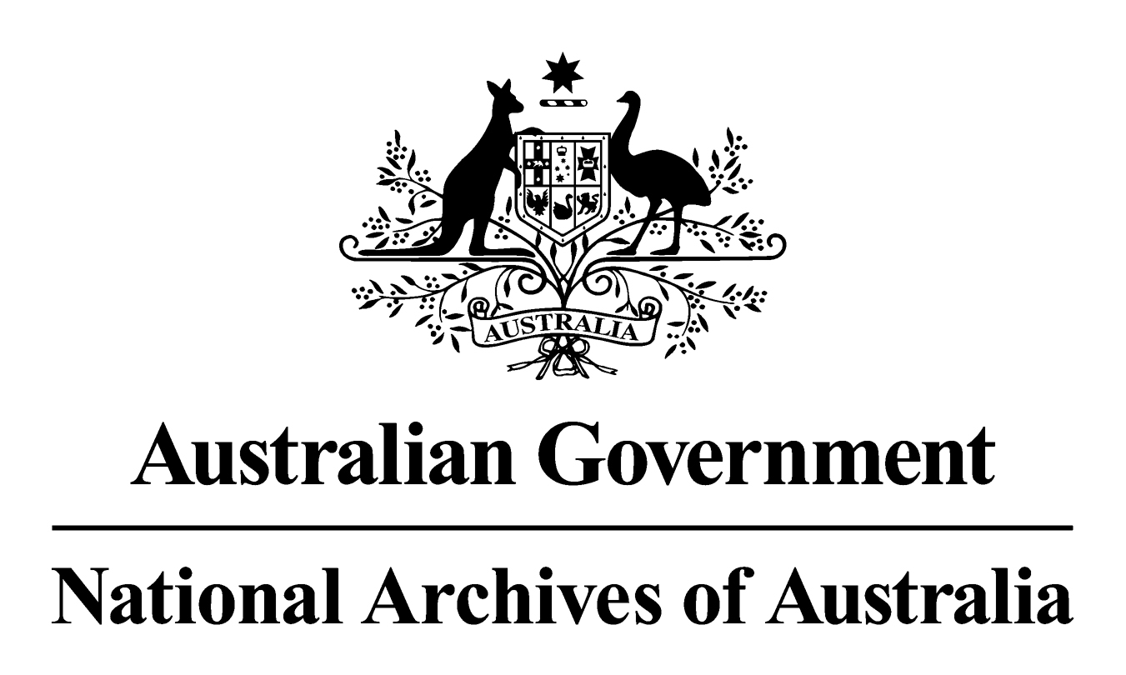

General Records Authority 39
2016/00471400

Public Interest Disclosure

2016

This is an accurate reproduction of the authorised records authority content,
created for accessibility purposes

© Commonwealth of Australia (National Archives of Australia) 2016
Copyright
This product, excluding the National Archives of Australia logo, Commonwealth Coat of Arms or registered trademark, has been licensed under a Creative Commons Attribution-Non-Commercial (CC-BY-NC) Version 4.0 International Licence. You may share, copy, redistribute, remix, transform and build upon this work for non-commercial purposes only. However, you must attribute the National Archives of Australia as the copyright holder of the original work, include the attribution as set out below and indicate if changes were made. The full terms and conditions of this licence are available at www.creativecommons.org.
Attribution
This records authority is licenced by the Commonwealth of Australia (National Archives of Australia) under a Creative Commons Attribution-Non-Commercial (CC-BY-NC) Version 4.0 International Licence. The original version can be found on our website.
Accessibility
This is an accurate reproduction of the authorised records authority content, created for accessibility purposes.
Contact Us
Enquiries relating to copyright or accessibility should be emailed to recordkeeping@naa.gov.au.

CONTENTS
INTRODUCTION 4
APPLICATION OF THIS AUTHORITY 4
CONTACT INFORMATION 5
AUTHORISATION 6
PUBLIC INTEREST DISCLOSURE 7

INTRODUCTION
The National Archives of Australia has developed this general records authority to set out the requirements for keeping or destroying agency records relating to public interest disclosure - disclosure and investigation of suspected wrongdoing in the Commonwealth public sector.
This authority is based on the identification and analysis of the business of public interest disclosures made in accordance with the Public Interest Disclosure Act 2013. It takes into account legal and organisational records, management requirements, and the interests of stakeholders, Australian government agencies and the National Archives of Australia.
The authority sets out those records that need to be retained as national archives and specifies the minimum length of time that temporary records need to be kept. This authority gives agencies permission under the Archives Act 1983, for the destruction of the temporary records described after the minimum retention period has expired. Retention periods for these temporary records are based on: an assessment of business needs; broader organisational accountability requirements; and community expectations.
As changes in circumstances may affect future records management requirements, this authority will occasionally require amendment by the addition of new classes or variation to existing classes. The National Archives will notify agencies of any changes and the information will also be published on the Archives website.
This authority commences on the date it is issued.

APPLICATION OF THIS AUTHORITY
- This authority is to be used to determine how long records must be kept. Records are matched to the relevant core business and records class in the authority.
- Where the minimum retention period has expired and the records are not needed for agency business they should be destroyed as authorised in this authority.
- Records that have not reached the minimum retention period must be kept until they do.
- Records that are identified as Retain as National Archives (RNA) are to be transferred to the National Archives of Australia for preservation.
- This authority should be used in conjunction with general records authorities such as:
AFDA Express which covers administrative business processes and records common to many Australian Government agencies;
General Records Authority 31 - Destruction of source or original records after digitisation, conversion or migration (2015).
- The Normal Administrative Practice (NAP) provision of the Archives Act 1983 gives agencies permission to destroy certain records without formal authorisation. This usually occurs where records are duplicated, facilitative or for short-term use only. NAP does not replace arrangements agreed to in this authority but can be used as a tool to assist in identifying records for destruction together with an agency's records authority or authorities, and with AFDA and AFDA Express. The National Archives recommends that agencies develop and implement a NAP policy. Advice and guidance on destroying records as a normal administrative practice and on how to develop a NAP policy is available from the National Archives' website at http://www.naa.gov.au/
- Records that are reasonably likely to be needed as evidence in a current or future judicial proceeding or are subject to a request for access under the Archives Act 1983, the Freedom of Information Act 1982 or any other relevant act must not be destroyed until the action has been completed.
- Records subject to a disposal freeze must not be destroyed until the freeze has been lifted. Further information about disposal freezes and whether they affect the application of this authority is available from the National Archives website at http://www.naa.gov.au/.

- Where the method of recording information changes (for example from a manual system to an electronic system, or when information is migrated from one system to a new system) this authority can still be applied, providing the records document the same function. The information must be accessible for the period of time prescribed in this authority. The agency will need to maintain continuing access to the information, including digital information, for the periods prescribed in this records authority or until the information is transferred into the custody of the National Archives.
- In general, retention requirements indicate a minimum period for retention. An agency may extend minimum retention periods if it considers that there is an administrative need to do so, without further reference to the National Archives. Where an agency believes that its accountability will be substantially compromised because a retention period or periods are not adequate, it should contact the National Archives for review of the retention period.
- Records coming within ‘retain as national archives' classes in this authority have been determined to be part of the archival resources of the Commonwealth under Section 3C of the Archives Act 1983. The determination of Commonwealth records as archival resources of the Commonwealth obliges agencies to transfer the records to the National Archives when they cease to be current and, in any event, within 15 years of the records coming into existence, under Section 27 of the Archives Act 1983.
- Records in the care of agencies should be appropriately stored, managed and preserved. Agencies need to meet this obligation to ensure that the records remain authentic and accessible over time. Under Section 31 of the Archives Act 1983, access arrangements are required for records that become available for public access including those records that remain in agency custody.
- Appropriate arrangements should be made with the National Archives when records are to be transferred into custody. The National Archives accepts for transfer only those records designated as national archives.
- Advice on how to use this authority is available from the agency's records manager. If there are problems with the application of the authority that cannot be resolved, please contact the National Archives.

CONTACT INFORMATION
For assistance with this authority or for advice on other information management matters, please contact National Archives’ Agency Service Centre.

Queen Victoria Terrace Email: recordkeeping@naa.gov.au
Parkes ACT 2600 Website: www.naa.gov.au
PO Box 7425
Canberra Business Centre ACT 2610

AUTHORISATION

RECORDS AUTHORITY 2016/00471400
Person to whom notice of authorisation is given: | Heads of Commonwealth Institutions under the Archives Act 1983 responsible for public interest disclosure records.

Purpose: | Authorises arrangements for the disposal of records in accordance with Section 24(2)(b) of the Archives Act 1983.  Determines records classed as ‘Retain as national archives’ in this records authority to be part of the archival resources of the Commonwealth under section 3C of the Archives Act 1983.
Application: | All functional records relating to public interest disclosure.

This authority gives permission for the destruction, retention or transfer to the National Archives of Australia of the records described. This authority will apply only with the consent of the agency currently responsible for the business documented in the records described.
Authorising Officer Date of issue:
Anne Lyons 8 December 2016
Assistant Director-General
National Archives of Australia

PUBLIC INTEREST DISCLOSURE
The function of receiving and managing public interest disclosures in the Commonwealth sector. It includes establishing and implementing governance frameworks for investigations and the protection of disclosers pursuant to the Public Interest Disclosure Act 2013 or any subsequent legislation.
Activities can include:
- Appointing authorised officers;
- Delegating powers and authorising actions;
- The receipt and assessment of disclosures;
- Conducting investigations and notifying relevant parties;
- Providing and receiving advice;
- Protecting current or former public officials from reprisals, retribution, and/or workplace conflict;
- Providing support and assistance to staff including claims for protection; and
- Reporting on investigation and actioning recommendations.
Cross references to AFDA Express Records Authority
For records documenting the agency-wide strategic management policies including public interest disclosure policy, USE STRATEGIC MANAGEMENT.
For records relating to reviews or evaluation of public interest disclosure policy, programs and operations, use STRATEGIC MANAGEMENT.
For records relating to investigations of misconduct or maladministration that are not specific to a public interest disclosure activity, use FINANCIAL MANAGEMENT, PROCUREMENT, PERSONNEL or STRATEGIC MANAGEMENT.
Class no | Description of records | Disposal action
62165 | Records relating to significant or high profile public interest disclosure investigations of major significance to the Australian Government, such as those which have set precedents, prompted a major change in policy or which have attracted media attention or community interest, and/or with far reaching social, economic, international implications.  Includes:  - the public interest disclosure investigation;  - evidence collected as part of an investigation;  - final report and associated follow up actions;  - research documents;  - working documents; and  - government responses to recommendations. | Retain as national archives.
62166 | Records (other than those covered in classes 62165, 62167, or 62168) relating to public interest disclosure activities including:  - the public interest disclosure investigation (including delegating powers and authorising actions, or investigations into PID activities which result in disciplinary action, or referral to action under other codes, or notifications to relevant parties);  - evidence (audio visual recordings, transcripts, statements of facts, correspondence and case notes) collected as part of an investigation;  - final report and associated follow up actions;  - research documents;  - working documents; and  - government responses to recommendations (including the management of false or misleading disclosures and development and implementation of awareness and training programs including communication materials). | Destroy 7 years after last action completed.
62167 | Records documenting public interest disclosures where:  - the allegations were not allocated for investigation because they were not considered an internal disclosure;  - the allegations were allocated for investigation but proved to be frivolous or vexatious and where there is no follow-up investigation;  - the allegations were investigated and proved to be unfounded and there are no findings or recommended actions, and the current or former public official has not requested the retention of records; or  - investigations not proceeded with. | Destroy 18 months after last action completed.
62168 | Records relating to public interest disclosure investigations where the allegations were proved unfounded and a current or former public official has requested the records to be retained. | Destroy 75 years after the birth of current or former public official or 7 years after last action, whichever is later.
62169 | Records documenting routine tasks supporting public interest disclosure activities, other than those covered in class 62166. | Destroy 2 years after last action.
62227 | Records relating to reprisals or threaten reprisal, relating to a public interest disclosure. | Destroy 15 years after last action completed

