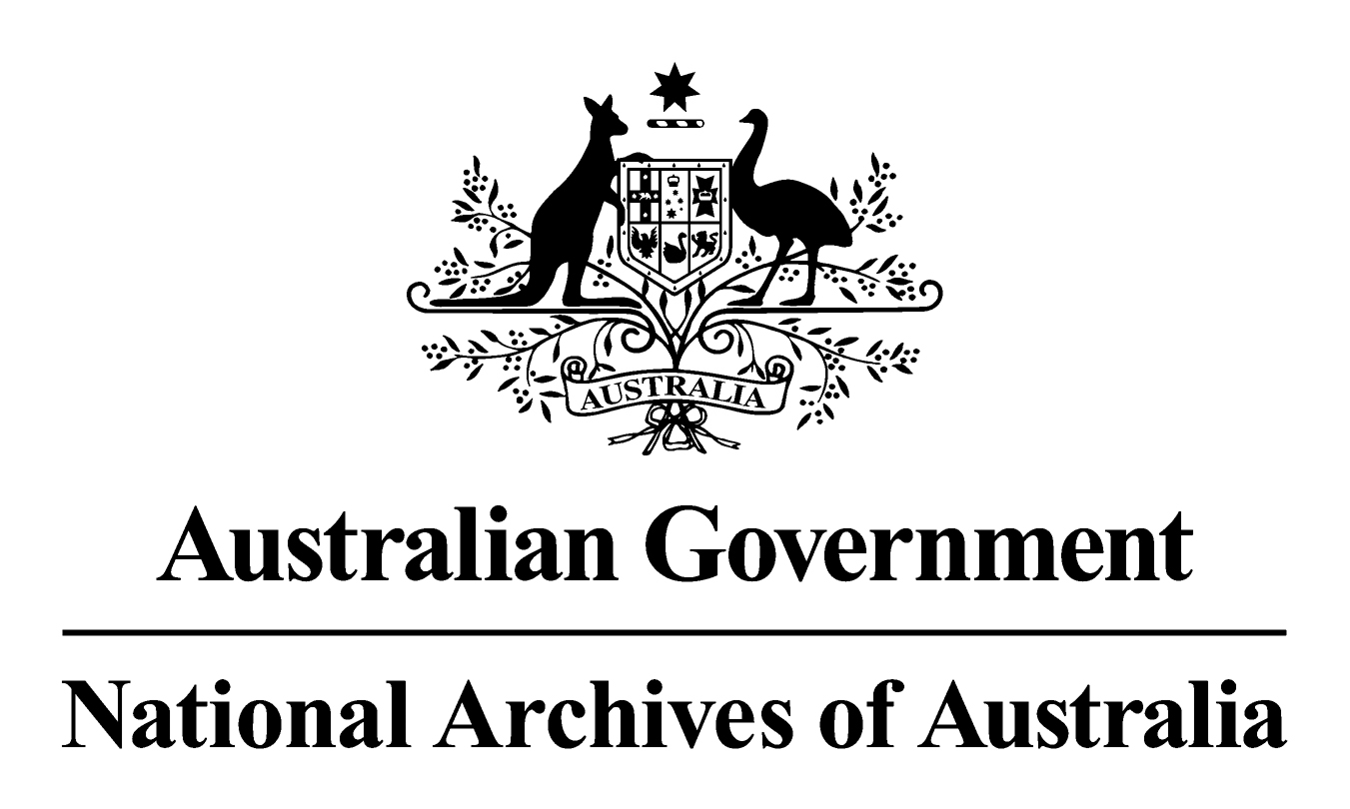

General Records Authority 35
2014/00396055

Removal of medical images produced on acetate bases
and
Photographic negatives produced on cellulose nitrate bases

2015

This is an accurate reproduction of the authorised records authority content,
created for accessibility purposes

CONTENTS

CONTENTS 2
INTRODUCTION 3
APPLICATION OF THIS AUTHORITY 3
CONTACT INFORMATION 3
AUTHORISATION 4
REMOVAL OF MEDICAL IMAGES PRODUCED ON ACETATE BASES AND PHOTOGRAPHIC NEGATIVES PRODUCED ON CELLULOSE NITRATE BASES 5

mmonwealth of Australia 2015
This work is copyright. Apart from any use as permitted under the Copyright Act 1968, no part may be reproduced by any process without prior written permission from the National Archives of Australia. Requests and inquiries concerning reproduction and rights should be directed to the Publications Manager, National Archives of Australia, PO Box 7425, Canberra Business Centre ACT 2610, Australia.

INTRODUCTION
Under Section 26 of the Archives Act 1983 a person must not engage in conduct that results in an addition or alteration to a Commonwealth record that has been in existence for more than 15 years unless the addition or alteration takes place with the permission of the Archives or is required by law.
The National Archives of Australia has developed this records authority to permit the removal of some records on unstable media, specifically medical images produced on an acetate base and photographic negatives on a cellulose nitrate base from their containers or paper files, for preservation and management.
These media can be found on case files maintained by agencies such as the Departments of Defence, Veterans Affairs and Immigration and Border Security. Many medical images on acetate bases are actively deteriorating. Cellulose nitrate as a film base is also highly flammable and is prone to rapid deterioration. This records authority permits the removal of these media from their files to mitigate the risk of damage to records stored close to them and the work safety of staff when handling these records.
Acetate film base was used between about 1930 and 1950. Cellulose nitrate film negatives were used from about 1885 until 1950.

APPLICATION OF THIS AUTHORITY
- This authority applies to all agencies and all relevant records as described, including those in the care of the National Archives.
- This authority gives permission to remove medical images on an acetate film base and photographic negatives on a cellulose nitrate base from their files. Removal of items from a file must be noted to ensure a permanent link is created for access purposes.
- The file and the medical image or photographic negative must be retained in accordance with relevant records authorities. If a relevant records authority does not exist, the records must be retained until an authority is issued.
- Records subject to a disposal freeze must not be destroyed until the freeze has been lifted. Further information about disposal freezes and whether they affect the application of this Authority is available from the National Archives website at www.naa.gov.au.
- Records in the care of agencies should be appropriately stored, managed and preserved. Agencies need to meet this obligation to ensure that the records remain authentic and accessible over time. Under Section 31 of the Archives Act 1983, access arrangements are required for records that become available for public access including those records that remain in agency custody.
- Appropriate arrangements should be made with the National Archives when records are to be transferred into custody. The National Archives accepts for transfer only those records designated as national archives.

CONTACT INFORMATION
For assistance with this authority or for advice on other records management matters, please contact the National Archives’ Agency Service Centre.

Queen Victoria Terrace Tel: (02) 6212 3610
Parkes ACT 2600 Fax: (02) 6212 3989
PO Box 7425 Email: recordkeeping@naa.gov.au
Canberra Business Centre ACT 2610 Website: www.naa.gov.au

AUTHORISATION

RECORDS AUTHORITY 2014/00396055
Person to whom notice of authorisation is given: | Heads of Commonwealth institutions under the Archives Act 1983

Purpose: | Authorises arrangements for the alteration of records in accordance with Section 26 of the Archives Act 1983.
Application: | Removal of medical images on acetate bases and photographic negatives on cellulose nitrate bases from their file.

This authority gives permission for the alteration of the records as described.
Authorised by Date of issue:
David Fricker 28 April 2015
Director-General
National Archives of Australia

REMOVAL OF MEDICAL IMAGES PRODUCED ON ACETATE BASES AND PHOTOGRAPHIC NEGATIVES PRODUCED ON CELLULOSE NITRATE BASES

Class no | Description of records | Disposal action
61741 | Files that contain medical images on acetate bases, including:  - CAT scans;  - nuclear scans;  - x-rays;  - ultrasounds; and  - dental images. | Remove image or negative from file and maintain in accordance with relevant Records Authorities
61742 | Files that contain photographic negatives of any size on cellulose nitrate bases. | Remove image or negative from file and maintain in accordance with relevant Records Authorities

