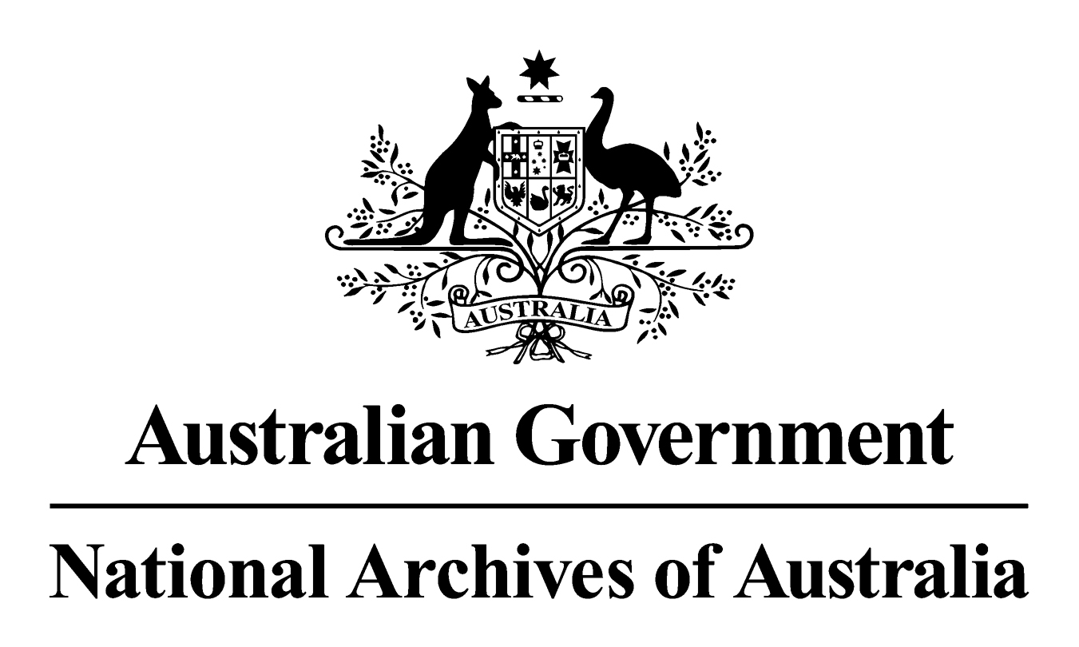

General Records Authority 34
2014/00444390

Establishing & winding up entities & companies

This is an accurate reproduction of the authorised records authority content, created for accessibility purposes

2015

CONTENTS

CONTENTS 3
INTRODUCTION 4
APPLICATION OF THIS AUTHORITY 4
CONTACT INFORMATION 5
AUTHORISATION 6
ESTABLISHING & WINDING UP ENTITIES & COMPANIES 6

INTRODUCTION
The National Archives of Australia has developed this Records Authority to set out the requirements for keeping or destroying records relating to certain governance arrangements of corporate and non-corporate Commonwealth entities and Commonwealth companies.
This General Records Authority is intended to cover only the records of establishing, non-routine reviewing, for example as a result of non-compliance, and winding up of these organisations. It also includes the records of appointments, including statutory appointments, to these entities and companies and the personnel records of staff employed under legislation other than the Public Service Act 1999 or previous legislation.
It takes into account legal and organisational records management requirements, and the interests of stakeholders, including Commonwealth agencies and the National Archives of Australia to preserve the archival resources of the Commonwealth.
The Authority sets out those records that need to be retained as national archives and specifies the minimum length of time that temporary records need to be kept. This Authority gives agencies permission under the Archives Act 1983, for the destruction of the temporary records described after the minimum retention period has expired. Retention periods for these temporary records are based on: an assessment of business needs; broader organisational accountability requirements; and community expectations.
As changes in circumstances may affect future records management requirements, this Authority may occasionally be amended by the addition of new classes or variation to existing classes. The National Archives will notify agencies of any changes and the information will also be published on the Archives website.

APPLICATION OF THIS AUTHORITY
- This Authority is to be used to determine how long records must be kept. Records are matched to the relevant core business and records class in the Authority:
- where the minimum retention period has expired and the records are not needed for agency business they should be destroyed as authorised in this Authority;
- records that have not reached the minimum retention period must be kept until they do; and
- records that are identified as Retain as National Archives (RNA) are to be transferred to the National Archives of Australia for preservation.
- This Authority should be used in conjunction with general records authorities such as:
- the Administrative Functions Disposal Authority (AFDA) and/or AFDA Express issued by the National Archives to cover business processes and records common to Australian Government agencies;
- General Records Authority 26 Advisory Bodies;
- General Records Authority 27 for Governing Bodies; and
- General Records Authority 31 for source (including original) records that have been copied, converted or migrated.
- This authority should also be used in conjunction with record authorities that relate to
agency-specific business. It does not supersede existing coverage in current records authorities and does not exclude coverage in future records authorities where an agency and the National Archives agree to the need for exceptions coverage.
- The Normal Administrative Practice (NAP) provision of the Archives Act 1983 gives agencies permission to destroy certain records without formal authorisation. This usually occurs where records are duplicated, facilitative or for short-term use only. NAP does not replace arrangements agreed to in this Authority but can be used as a tool to assist in identifying records for destruction together with an agency’s Records Authority or Authorities, and with AFDA and AFDA Express. The National Archives recommends that agencies develop and implement a Normal Administrative Practice policy. Advice and guidance on destroying records as a normal administrative practice and on how to develop an agency NAP policy is available from the National Archives’ website at www.naa.gov.au.
- Where the method of recording information changes (for example from a manual system to an electronic system, or when information is migrated from one system to a new system) this Authority can still be applied, providing the records document the same core business. The information must be accessible for the period of time prescribed in this Authority. The agency will need to maintain continuing access to the information, including digital information, for the periods prescribed in this records authority or until the information is transferred into the custody of the National Archives.
- Records that are reasonably likely to be needed as evidence in a current or future judicial proceeding or are subject to a request for access under the Archives Act 1983, the Freedom of Information Act 1982 or any other relevant Act must not be destroyed until the action has been completed.
- In general, retention requirements indicate a minimum period for retention. Agencies may extend minimum retention periods if they consider that there is an administrative need to do so, without further reference to the National Archives. Where a Commonwealth agency believes that its accountability will be substantially compromised because a retention period or periods are not adequate, it should contact the National Archives for review of the retention period.
- Records subject to a disposal freeze must not be destroyed until the freeze has been lifted. Further information about disposal freezes and whether they affect the application of this Authority is available from the National Archives website at www.naa.gov.au.
- Records in the care of agencies should be appropriately stored, managed and preserved. Agencies need to meet this obligation to ensure that the records remain authentic and accessible over time. Under Section 31 of the Archives Act 1983, access arrangements are required for records that become available for public access including those records that remain in agency custody.
- Appropriate arrangements should be made with the National Archives when records are to be transferred into custody. The National Archives accepts for transfer only those records designated as national archives.
- Advice on how to use this Authority is available from your agnecy’s records manager. If there are problems with the application of the Authority that cannot be resolved, please contact the National Archives.

CONTACT INFORMATION
For assistance with this authority or for advice on other records management matters, please contact National Archives’ Agency Service Centre.
Queen Victoria Terrace Tel: (02) 6212 3610
Parkes ACT 2600 Fax: (02) 6212 3989
PO Box 7425 Email: recordkeeping@naa.gov.au
Canberra Business Centre ACT 2610 Website: www.naa.gov.au

AUTHORISATION

GENERAL RECORDS AUTHORITY 2014/00444390
Person to whom notice of authorisation is given: | Heads of Commonwealth institutions under the Archives Act 1983 responsible for the records of establishing and winding up entities and companies.

Purpose: | Authorises arrangements for the disposal of records in accordance with Section 24(2)(b) of the Archives Act 1983.  Determines records classed as ‘Retain as national archives’ in this Records Authority to be part of the archival resources of the Commonwealth under section 3C of the Archives Act 1983.
Application: | All core business records relating to establishing & winding up entities & companies.

This authority gives permission for the destruction, retention or transfer to the National Archives of Australia of the records described. This authority will apply only with the consent of the agency currently responsible for the business documented in the records described.
Authorised by: Date of issue:
Louise Doyle 19 March 2015
Director-General A/g
National Archives of Australia

ESTABLISHING & WINDING UP ENTITIES & COMPANIES
The core business of starting and winding up entities and companies which are established as separate Commonwealth bodies. It includes activities that are a part of establishing a new body, such as notification, registration and incorporation. Winding up entities and companies includes revocation and dissolution, for example by deregistration, liquidation, sale, merger or consolidation.
This authority includes reviewing of governance arrangements in unusual circumstances, for example as a result of compliance issues or controversy. It also includes managing statutory appointments and the personnel records of staff employed by the entity or company under legislation other than the Public Service Act 1999 or previous legislation.
Note: It excludes regular day-to-day governance arrangements and ‘business as usual’ reviewing and reporting which are covered by AFDA Express STRATEGIC MANAGEMENT. It also excludes the core business records of the entity or company.
The core activities include:
- establishing governance arrangements;
- winding up governance arrangements;
- advising, reporting and reviewing of governance arrangements in unusual circumstances, for example as a result of compliance issues or controversy;
- managing appointments, including statutory appointments, agreements and separations; and
- transferring or selling assets and liabilities of the entity or company after wind up.
The performance of the core business is supported by general activities such as:
- managing meetings and committees;
- receiving and responding to enquiries;
- planning and reporting.
Cross references to the AFDA Express Records Authority
For overseeing regular governance arrangements, reporting corporate plans and strategies, use STRATEGIC MANAGEMENT.
For managing the formal relationship between the entity or company and other government bodies, use GOVERNMENT RELATIONS.
For media relations, use COMMUNITY RELATIONS.
For managing, acquiring, constructing, fitting-out, maintaining, protecting and disposing of entity or company premises, use PROPERTY MANAGEMENT.
For managing and reporting on the finances of entities and companies, use FINANCIAL MANAGEMENT.
For the management of personnel employed under the Public Service Act 1999, and volunteer workers, use PERSONNEL.
Cross references to other records authorities
For managing regular business, including membership of advisory bodies, use GRA 26 ADVISORY BODIES.
For managing the membership and administration of governing bodies, use GRA 27 GOVERNING BODIES.

Class no | Description of records | Disposal action
61651 | The following significant records documenting:  - establishing governance arrangements of entities and companies. Includes notification regarding the establishment of entities and companies; certificates of incorporation; Memoranda and Articles of Association, Articles of Incorporation and by-laws; and corporate seals;  - arrangements for winding up entities and companies, including deregistering, liquidating, selling and merging or consolidating in another body. Includes government approval; negotiations and directions; shareholder or minister variations to facilitate the sale or wind-up; and reports presented to or by the board, on the sale or wind-up;  - reviews of governance arrangements in unusual circumstances, for example as a result of compliance issues or controversy. Includes outcomes such as agreements to merge or consolidate, plans to reorganise or revocation. Includes high level advice, directions, briefings and reports provided to or by the Minister; directions issued to an entity or company including initial and approved plans, reorganisation plans lodged by entities with regulatory authorities, technical advice, supporting documents and reviews of plans; and  - instruments of appointment or summary membership records, for example a register of appointments. | Retain as national archives
61652 | Records documenting a consolidated employment history of individuals appointed to positions, including statutory positions, under legislation other than the Public Service Act 1999 or previous legislation. Includes:  - terms of appointment;  - declarations of interest;  - consolidated leave history;  - records of nominating, electing, appointing and re-appointing members. Includes individual agreements or contracts with members, signed codes of conduct, gazettal notices, letters of appointment or reappointment;  - legal advice regarding employment conditions;  - remuneration records (both monetary and non-monetary), including pay histories, records relating to the recovery of overpayments;  - training and professional development received;  - separation records documenting retirements, resignations, dismissals, death and dispensation of services;  - accident or incident reports for injury, death, loss or damage to personal property; and  - compensation claims case records (eg rehabilitation records, medical reports, appeals, legal records relating to the case, progress and assessment reports).  Note: Excludes records of governing body and advisory body members. | Destroy 75 years after date of birth or 7 years after last action, whichever is the longest
61653 | Records documenting:  - routine operational administrative tasks supporting the business; and  - entity and company establishment and winding up activities, other than those covered in classes 61651 and 61652. | Destroy 7 years after action completed

