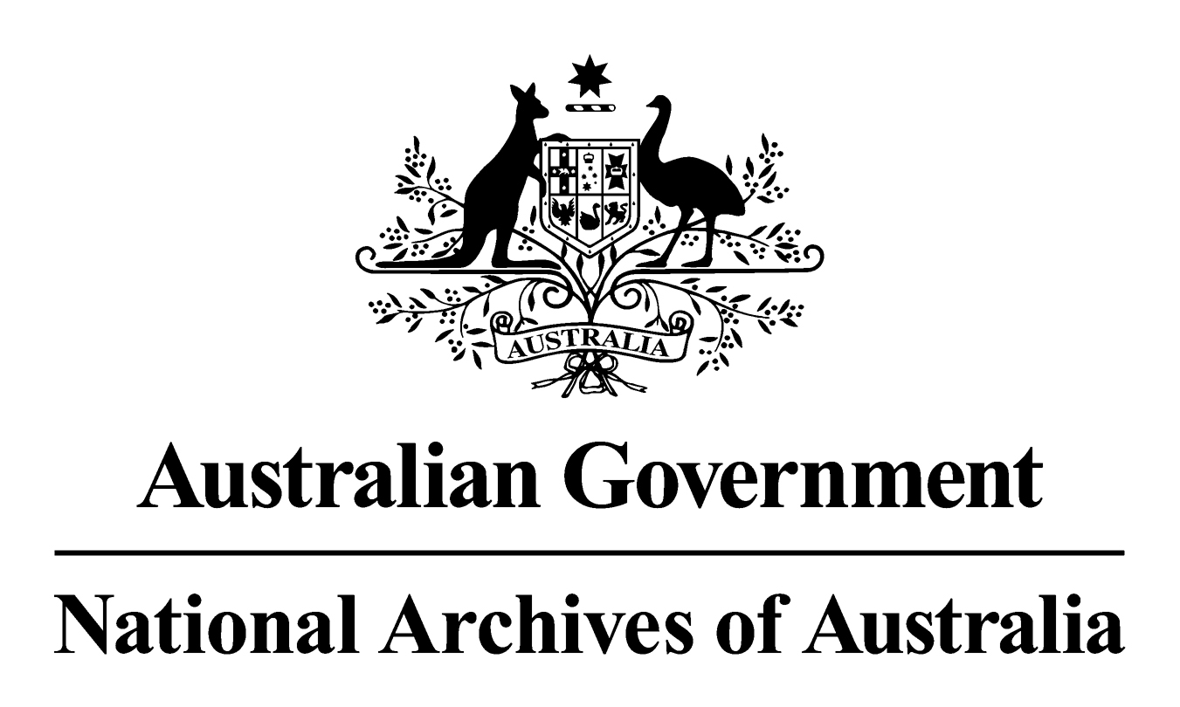

General Records Authority

Governing Bodies

General Records Authority No. 27
24 June 2010
CONTENTS

INTRODUCTION 3

APPLICATION OF THIS AUTHORITY 3

CONTACT INFORMATION 4

AUTHORISATION 5

CLASSES 6

GOVERNING BODIES 6
INTRODUCTION
mmonwealth of Australia 2010
This work is copyright. Apart from any use as permitted under the Copyright Act 1968, no part may be reproduced by any process without prior written permission from the National Archives of Australia. Requests and inquiries concerning reproduction and rights should be directed to the Publications Manager, National Archives of Australia, PO Box 7425, Canberra Mail Centre ACT 2610, Australia.

The National Archives of Australia has developed this Records Authority to set out the requirements for keeping or destroying the records of governing bodies.

Purpose
This Authority identifies minimum retention periods for records relating to the business of governing bodies and authorises the destruction or retention of these records as required by Section 24 of the Archives Act 1983. It is issued for use across the Commonwealth.
Governing bodies may use the following tools to dispose of their records:
- this General Records Authority, covering the business performed by governing bodies;
- the Administrative Functions Disposal Authority (AFDA), covering administrative functions commonly performed by most Commonwealth agencies;
- AFDA Express, a streamlined version of AFDA;
- other General Records Authorities (GRAs), covering business performed by many agencies; and
- normal administrative practice (NAP), which allows for the destruction of records where the records are duplicated, unimportant or for short-term use only.
As changes in circumstances may affect future records management requirements, this Authority will occasionally require amendment by the addition of new classes or variation to existing classes. The National Archives will notify agencies of any changes and the information will also be published on the Archives website.

APPLICATION OF THIS AUTHORITY
1. This Authority should be used in conjunction with:
- AFDA Express, or
- AFDA
2. This Authority should also be used in conjunction with GRAs issued by the National Archives that cover other types of records that may be created by a governing body, such as encrypted records and source records that have been copied.
3. This Authority is to be used to determine whether Governing Bodies records should be kept, destroyed or transferred to the National Archives. The disposal action set out in the Authority is the minimum retention period. A record can be kept for longer, but it cannot be destroyed before that date. Records designated as national archives (RNA) should be transferred to the National Archives when the agency's regular business need for the records ceases. Arrangements should be made with the National Archives when records are to be transferred.
4. Where the method of recording information changes (for example from a manual system to an electronic system or when information is migrated from one system to a new system) this Authority can still be used to sentence records created, providing the records document the same business. The information must be accessible for the period of time prescribed in this Authority. Agencies will need to ensure that any software, hardware or documentation required to enable continuing access to the information is available for the periods prescribed.
5. In general, retention requirements indicate the minimum period for retention. Agencies may extend minimum retention periods if there is an administrative need to do so without further reference to the National Archives. Where the governing body believes that its accountability will be substantially compromised because a retention period or periods are not adequate, it should contact the National Archives for review of the retention period.
6. The Normal Administrative Practice (NAP) provision of the Archives Act gives agencies permission to destroy certain records without formal authorisation. This usually occurs where records are duplicated, facilitative or for short-term use only. NAP does not replace arrangements agreed to in this Authority but can be used as a tool to assist in identifying records for destruction together with an agency's Record Authority or Authorities, and with AFDA and AFDA Express. The National Archives recommends that agencies develop and implement a Normal Administrative Practice policy to assist in planning and implementing activities to determine whether records should be kept or destroyed. Advice and guidance on destroying records as a normal administrative practice and on how to develop an agency NAP policy is available from the National Archives' website at www.naa.gov.au
7. Prior to records destruction, it is important to note any relevant disposal freezes. The National Archives places a disposal freeze on some groups of records to prevent their destruction. These generally relate to groups of records relating to a particular topic or event which has gained prominence or provokes controversy. While the freeze is in place, no records relating to the topic or event may be destroyed. Further information about current disposal freezes and whether they affect the application of this Authority is available from the National Archives website at www.naa.gov.au/records-management/keep-destroy-transfer/freezes
8. Records in the care of agencies should be appropriately stored and preserved. Agencies need to meet this obligation to ensure that the records remain authentic and accessible over time. Under Section 31 of the Archives Act 1983, access arrangements are required for records that are in the open access period (currently after 30 years).
9. Arrangements should be made with the National Archives when records are to be transferred into custody. The National Archives accepts for transfer only those records designated as national archives (RNA).
10. Advice on how to use this Authority is available from your agency’s Records Manager. If there are problems with the application of the Authority that cannot be resolved, please contact the National Archives.

CONTACT INFORMATION
For assistance with this authority or for advice on other recordkeeping matters, please contact National Archives’ Agency Service Centre.
Queen Victoria Terrace Tel: (02) 6212 3610
Parkes ACT 2600 Fax: (02) 6212 3989
PO Box 7425 Email: recordkeeping@naa.gov.au
Canberra Mail Centre ACT 2610 Website: www.naa.gov.au

AUTHORISATION
RECORDS AUTHORITY
Person to whom notice of authorisation is given: | Heads of Commonwealth Institutions under the Archives Act 1983 responsible for the records of governing bodies

Purpose: | AUTHORISES ARRANGEMENTS FOR THE DISPOSAL OF RECORDS IN ACCORDANCE WITH SECTION 24(2)(b) OF THE ARCHIVES ACT 1983  Ref: Job No. 2010/00182807
Application: | Records of Governing Bodies

This authorisation gives permission for the destruction, retention or transfer to the National Archives of Australia of the records described. The Authority will apply only if these actions take place with the consent of the agency responsible for the business documented in the records.

Authorising Officer Date of issue:
Ross Gibbs
Director-General

National Archives of Australia
The business of establishing membership and managing the administration of governing bodies, such as boards, trusts, councils, commissions and so on, that direct, oversee or provide a framework for the control of an organisation. Includes governing bodies regulated by the Commonwealth Authorities and Companies Act 1997 (or its equivalent). Covers activities associated with providing secretariat support to the governing body in the performance of its duties and administrative support to governing body members, including arrangements for travel, leave entitlements, allowances and remuneration for duties performed. Also includes the nomination, election, appointment and separation of governing body members, disclosures of pecuniary interests, professional indemnity insurance, relations between an organisation and its governing body and meetings of governing bodies. Excludes governing bodies that do not undertake a governance role.

Note: Governing Bodies is a business area relating to the agency’s governance management. The other governance business area is Strategic Management which covers broad systematic administration, planning and reporting. The focus of the Governing Bodies is the establishment and day-to-day administration of an agency’s internal governing authority. The activities of the governing body support other business areas, in particular Community Relations, Government Relations, Strategic Management, and all other agency core businesses where they are covered.

Governing bodies does not cover the activities of advisory bodies. Governing bodies have executive powers and focus on administrative control of an agency’s governance framework while advisory bodies provide informed advice to the Minister, the Government and the agency. Advisory bodies undertake no role in governance activities. Their administration and operations are covered by a separate general records authority issued by the National Archives.

This business area includes such governing bodies’ related activities as:

- managing accidents involving members of governing bodies;
- supporting the development of addresses (presentations);
- negotiating and establishing agreements (eg contracts of appointments);
- handling appeals;
- managing compensation cases;
- managing disclosures of interest;
- administering leave;
- administering meetings of governing bodies;
- managing membership of governing bodies (i.e. establishment and composition);
- supporting performance management frameworks;
- managing remuneration arrangements; and
- supporting training requirements.

The performance of the business area is supported by routine administrative tasks such as:

- providing and receiving advice;
- complying with external management requirements;
- delegating powers and authorising actions;
- managing insurance and claims;
- managing administrative meetings;
- planning, researching, reporting and reviewing; and
- developing policies and procedures.

For establishing and changing the structure of an organisation, use ESTABLISHMENT.

For the broad systematic administrative management of an organisation, use STRATEGIC MANAGEMENT.

For managing the acquisition of goods and services, and tendering and contracting arrangements to support governing bodies, use PROCUREMENT.

For managing financial activities relating to governing bodies, use FINANCIAL MANAGEMENT.

Class No. | Description of records | Disposal action
21579  *21579* | The following significant records documenting administrative activities of governing bodies:  - minutes and supporting records of meetings of governing bodies;  - performance expectation records for governing bodies (eg final version of performance agreements, statements of intent, negotiations);  - policies supporting the administration and operation of governing bodies (eg charters and codes of conduct for members);  - formal reports on the administration and operation of governing bodies; and  - summary membership records (eg registers of members or appointments, disclosures of interest, and related party transactions. Where no summary disclosure of interest registers exist, and are not included in the minutes of governing body meetings, retain records documenting notification and receipt of disclosures).  [For governing body records that do not fall into the significant category of 21579, or are not related to records of individual governing body members detailed in 21580, use GOVERNING BODIES – 21581.  For reports of governing bodies and committees established by governing bodies that impact on the broad overall management of the agency, use AFDA Express STRATEGIC MANAGEMENT – 20340 or 20342.  For records of committees established by the governing body relating to a particular administrative activity or core business, use the relevant AFDA Express function or agency core business.] | Retain as national archives
21580  *21580*  (cont) | Administrative records of the following activities supporting the membership of individual governing body members with long term requirements, excluding those detailed in classes 21579 and 21581:  - accident/incident reports for injury, death, loss or damage to personal property;  - compensation claim/case records (eg rehabilitation records, medical reports, appeals, legal records relating to the case, progress and assessment reports);  - consolidated leave history records;  - nominating, electing, appointing and re-appointing members. Includes individual agreements/contracts with members, signed codes of conduct, gazettal notices, letters of appointment or re-appointment;  - notification of appointments to regulatory bodies (eg ASIC);  - remuneration records (both monetary and non monetary) including pay histories, records relating to the recovery of over-payments;  - separation records covering retirements, resignations, dismissals, death and dispensation of services; and  - terms of appointment.  [For summary records facilitating the management of membership of governing bodies (eg registers of appointments), use GOVERNING BODIES – 21579.  For records of individual governing body members that are not summary records noted in 21579, and are not listed in 21580, use GOVERNING BODIES – 21581.] | Destroy 75 years after date of birth of the governing body member or 7 years after last action, whichever is longest. For accident records, if date of birth is unknown assume the person was 15 at the time of the accident
21581  *21581* | Records documenting:  - routine operational administrative tasks supporting the business area; and  - governing bodies activities, other than those covered in classes 21579 and 21580.  [For advice received from or provided to the portfolio minister or government agencies, use AFDA Express GOVERNMENT RELATIONS – 20267 or 20270.  For responses to ‘Ministerials’, use AFDA Express GOVERNMENT RELATIONS – 20267 or 20269.  For addresses and presentations made by members of governing bodies, use AFDA Express COMMUNITY RELATIONS – 20439.  For liaison between members of governing bodies and professional associations, private-sector organisations and community groups, use AFDA Express COMMUNITY RELATIONS – 20443.  For records of committees established by the governing body relating to a particular administrative activity or core business, use the relevant AFDA Express function or agency core business.] | Destroy 10 years after action completed or after member’s separation, whichever is relevant

