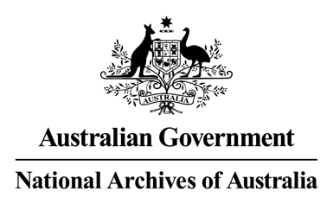

General Records Authority

Transfer of custody and ownership of

Personal Security Files (PSFs) Job no 2008/00174731

18 April 2008

©Commonwealth of Australia 2008

This work is copyright. Apart from any use as permitted under the *Copyr ight Act 1968,* no part may be reproduced by any process without prior written permission from the National Archives of Australia. Requests and inquiries concerning reproduction and rights should be directed to the Publications Manager, National Archives of Australia, PO Box 7 425, Canberra Mail Centre ACT 2610, Australia.

**CONTENTS**

**INTRODUCTION 5**

**AUTHORISATION 7**

**APPLICATION OF THIS AUTHORITY 8**

**CONTACT INFORMATION 8**

**CLASSES 9**

[This page has been left blank intentionally.]

**INTRODUCTION**

The National Archives of Australia, in consultation with the Attorney General's Department, has developed this authority to permit the transfer of Personal Security Files (PSFs) to State and Territory government agencies and police services. This follows the signing, in 2007, of a memorandum of understanding between the Commonwealth and all States and Territories for the protection of national security information. One of the agreed arrangements is that the parties will apply the minimum standards of the Australian Government Protective Security Manual (PSM).

Under the PSM, agencies should keep PSFs for all employees and contracted service providers with a security clearance, and for some uncleared people. The PSM also notes that PSFs are intended to be portable between agencies, subject to certain limitations outlined in the PSM. The extension of the PSM scheme to State and Territory agencies opens the way for PSFs to be portable between agencies in different jurisdictions.

PSFs raised by Commonwealth agencies are Commonwealth records subject to the *Archives Act 1983*. The Archives Act prohibits the transfer of the custody or ownership of Commonwealth records, subject to a number of exceptions. This authority gives Commonwealth agencies the permission they require under the Archives Act to transfer Commonwealth PSFs to agencies in other jurisdictions. The transfer of PSFs between Commonwealth agencies in accordance with the PSM is a long-standing normal administrative practice of which the Archives does not disapprove.

PSFs that remain with Commonwealth agencies should be retained in accordance with the PSM. Their destruction, when eligible, is authorised by the Administrative Functions Disposal Authority (AFDA) in the section PERSONNEL – Security, and a separate authority for Defence Military personnel. These arrangements also apply to PSFs whose ownership has transferred to Commonwealth agencies from State and Territory agencies and police services.

Any amendment of this authority must be approved by the National Archives. Officers using the authority should advise the National Archives of any changes considered desirable.

Advice on using this authority and other recordkeeping matters is available from the National Archives’ website at [www.naa.gov.au](http://www.naa.gov.au/) or by contacting the Agency Service Centre at [recordkeeping@naa.gov.au](mailto:recordkeeping@naa.gov.au) or (02) 6212 3610.

[This page has been left blank intentionally.]

AUTHORISATION

GENERAL RECORDS AUTHORITY: Transfer of custody and ownership of Personal Security

Files (PSFs)

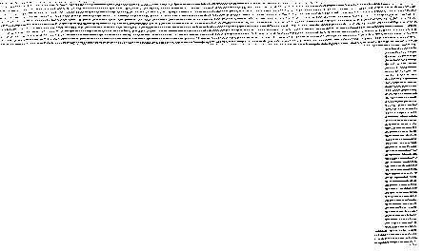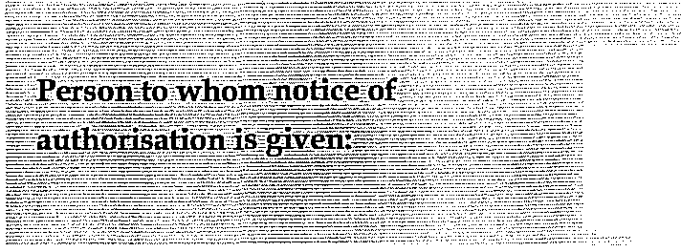

Heads of Commonwealth institutions under the *Archives Act 1983.*

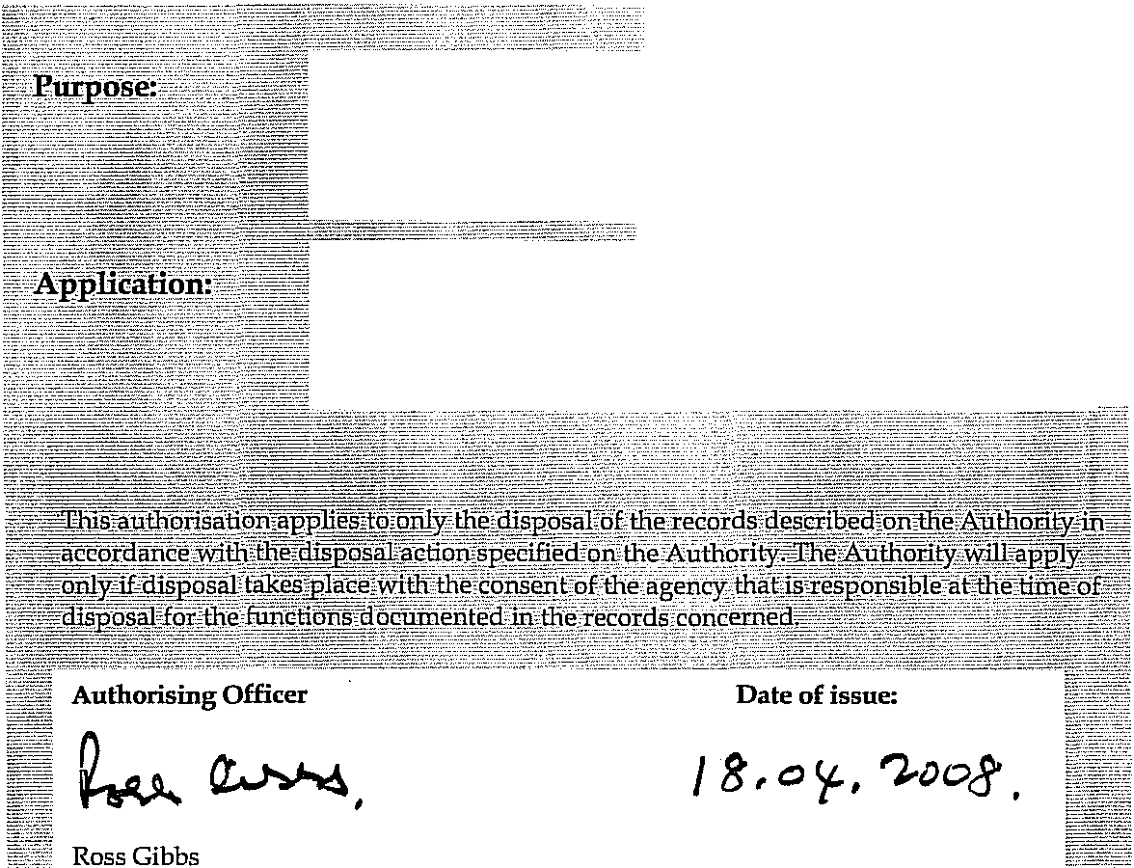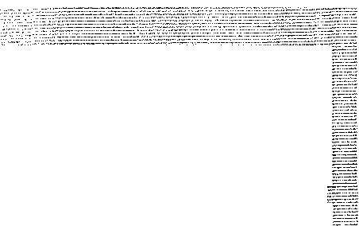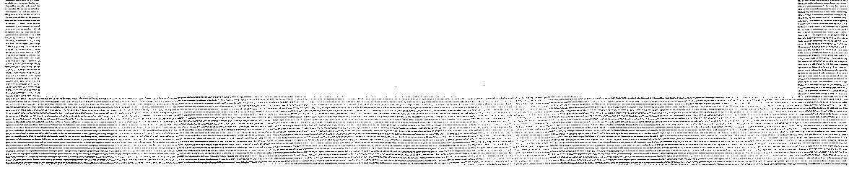

Authorises arrangements for the transfer of records in accordance with Section 24(2)(b) of the Archives Act 1983.

Permits the transfer of custody or ownership of Personal Security Files (PSFs) to State and Territory government agencies and police services in accordance with the Protective Security Manual.

Director-General

National Archives of Australia

*7*

**APPLICATION OF THIS AUTHORITY**

1. This authority applies only to those Commonwealth PSFs, including individual documents in a PSF, that are eligible to be transferred between agencies in accordance with the Australian Government Protective Security Manual (PSM) as amended from time to time. Refer to the PSM for eligibility details.

2. The transfer permission is given on the understanding that physical transfer arrangements will be in accordance with the PSM and subsequent management, including destruction where relevant will, subject to State or Territory legislation, be in accordance with the PSM.

3. This authority does not cover the transfer of PSFs for Defence military personnel.

4. Where only the custody of PSFs is transferred, the PSFs should be recovered by the agency concerned when they cease to be needed by the relevant State or Territory government agency or police service.

5. Any additions made by the State or Territory government agencies or police services to PSFs whose custody has been temporarily transferred to them will be treated as Commonwealth records.

6. If the temporary transfer of a person becomes permanent, the ownership of the PSF may be transferred to the relevant State or Territory government agency or police service.

7. For temporary transfers up to 6 months the same principle that applies to transfers between Commonwealth agencies should be applied: that is, the PSF should normally stay with the originating agency.

8. The Archives Act 1983 does not apply to PSFs whose ownership has transferred from the Commonwealth or a Commonwealth institution to a State or Territory government agency or police service. Notification of the destruction of these PSFs to the National Archives is not required. The Commonwealth will not have further access to these PSFs other than as provided for under the PSM framework, the *Memorandum of Understanding for the Protection*

*of National Security Information* or by separate agreement.

**CONTACT INFORMATION**

For assistance with this Authority or for advice on other recordkeeping matters, please contact

National Archives’ Agency Service Centre**.**

Queen Victoria Terrace Tel: (02) 6212 3610

Parkes ACT 2600 Fax: (02) 6212 3989

PO Box 7425 Email: [recordkeeping@naa.gov.au](mailto:recordkeeping@naa.gov.au)

Canberra Mail Centre ACT 2610 Website: [www.naa.gov.au](http://www.naa.gov.au/)

**GENERAL RECORDS AUTHORITY**

**Transfer of custody and ownership of Personal Security Files (PSFs)**

***Entry Description of Records Disposal Action***

|  |  |  |
| --- | --- | --- |
| 19312 | Personal security files (PSFs) of persons who take up permanent employment with, or are engaged as contractors by, State or Territory government agencies or police services.  Excludes PSFs for Defence military personnel. | Transfer custody and ownership to the relevant State or Territory government agency or police service upon request. |
| 19313 | Personal security files (PSFs) of persons who are temporarily transferred to State or Territory government agencies or police services.  Excludes PSFs for Defence military personnel. | Transfer custody to the relevant State or Territory government agency or police service upon request. |

9